IMLEMENTATION OF TOTAL QUALITY MANAGEMENT
MODEL IN CROATIAN BUREAU OF STATISTICS



CONTENTS

PREFACE 4

ABBREVIATIONS 5

INTRODUCTION 6

0. Total Quality Management - TQM 8

1. Statistical processes and products of good quality 10

1.1 Monitor quality in statistics 10
1.2 Report on quality 10
1.3 Introduce pilot phases for quality testing 11

2. Satisfied users with statistical data 12

2.1 Implement modern dissemination tools in accordance with the users neeeds 13
2.2 Develop relationships with users (regular monitoring of user needs) 13
2.3 Establish metadata management system 14
2.4 Establish data protection on data confidentiality 16
2.5 User satisfaction 17

3. Reduce the response burden of respondents 22

3.1 Increase the use of administrative data sources 22
3.2 Increase the use of electronic questionnaires 23
3.3 Burden the respondents equally 24

4. Effectiveness of statistical processes 24

4.1 Optimise processes 24
4.2 Establish the planning system and the controlling instruments 25
4.3 Optimise the project management 26

5. Vocational guidance of staff 26

5.1 Educate staff continuously 26
5.2 Monitor the satisfaction level of CBS staff 27
5.3 Improve communication within the staff on all levels 29

LITERATURE 30

PREFACE

The Activities of the Croatian Bureau of Statistics (hereinafter CBS) that refer to the quality improvement of the statistical processes and statistical products are focused on the development of all their quality aspects. Their quality is the basic prerequisite for both the stable development of CBS statistics, and the strengthening of the reputation of the entire national and European statistical system.

Currently monitored are the quality of statistical processes and statistical products for some, but not all, of CBS statistics. Since 2010, when the brief review of the implementation of the European Statistics Code of Practice was carried out in Croatia, called Light Peer Review, the number of new quality reports for CBS statistical outputs increased significantly, as well as the number of handbooks and methodologies for assessing and monitoring quality.

What is all the time missing in the CBS is a systematic approach to quality management, especially in the preparing and implementing of quality management models. Therefore, CBS has implemented a project on establishing a system for the quality documentation of statistical processes and statistical products, which includes the preparation and establishment of a model that will enable the management of quality in CBS in line with European standards.

Thanks to the IPA 2009 project, and Technical Assistance of the German company GOPA, set out in this document is the basis for quality management of the Republic of Croatia in a systematic way based on the procedures, that are going to be upgraded and broadened during the next few years..

Since this is a very complex project, I am using this opportunity to thank the many contributors that participated in the project in any way. Particularly thanks again to GOPA – Gesellschaft für Organisation, Planung und Ausbildung mbH (GOPA Consultants), who within the project IPA 2009 organised all the necessary activities for the successful realisation of this quality management project.

DIRECTOR GENERAL

Marko Krištof
ABBREVIATIONS

CBS | Croatian Bureau of Statistics
ESS | European Statistical System
ESSC | European Statistical System Committee
ESTP | European Statistical Training Programme
EU | European union
GSBPM | Generic Statistical Business Process Model
GOPA | Gesellschaft für Organisation, Planung und Ausbildung mbH
IPA | Integrated preaccession fund
IT | Information technologies
MS | Microsoft
SAS | Statistical Analysis System
TQM | Total Quality Management
UN | United Nations

INTRODUCTION

The activities of the CBS, in terms of quality improvement, are focused on all quality aspects of the statistical processes and statistical products that are being continuously developed and improved in line with ESS recommendations.

Availability of high-quality and timely statistical information is necessary for the development and monitoring of specific policies, particularly in relation to their impact and the fulfilment of their objectives. After joining the European Union, besides national development goals, the Republic of Croatia will also direct its efforts to the achievement of common strategic objectives of the EU, which represents an additional challenge in terms of the quality and structural characteristics of statistical data.

As a member state of the European family, CBS is committed to provide an optimal level of quality of statistical processes and statistical products, to use statistical methods and processes in accordance with internationally recognised principles and standards, and to continuously conduct analyses with the aim to improve the quality of statistical processes and products. During the adoption of the European Statistics Code of Practice, the CBS as well as the other national statistical institutes of EU Member States will out to comply with the principles and standards necessary for the production and distribution of quality statistical products.

Mission

The mission of the CBS is focused on building its statistical system that produces unbiased statistical information about the social and economic processes by providing the facts necessary for monitoring and analysing the status of the Croatian economy, and so helping in the directing of policies associated with the development of Croatian society, economy and politics of the European Union.
The Croatian statistical system provides access to a broad set of internationally comparable and standardised information on socio-economic developments in Croatia, by applying the best international experiences regarding collecting, processing and dissemination methods of data, and the principles of efficiency, customer orientation and continuous improvement of the CBS human resources..

Vision

The vision of the CBS as the main producer and coordinator of official statistics is based on the following objectives:
- Efficiency and innovation during the task performance, implementation of modern technologies and use of electronic communication forms
- Inclusion in socio-economic phenomena
- User orientation
- Attractiveness of hiring experts from various scientific fields

Values

In order to achieve the targeted mission and vision the statistical system is based on two fundamental values:
- Production and publication data of high-quality, objective, comparable and timely statistical data
- Continuous cooperation of all representatives of official statistics in the country and abroad, in order to achieve the best possible results.

European Statistics Code of Practice

The European Statistical System (ESSC) adopted the European Statistics Code of Practice and published in the Commission Recommendation (2005) its directions on the independence, integrity and accountability of the national statistical offices and institutions of the EU in February 2005. The European Statistics Code of Practice is based on 15 principles covering the institutional environment, the statistical production processes and the statistical results. The objective within the ESS system is not only to ensure that the data produced are statistically relevant, timely and accurate but also to ensure that they are in accordance with the principles of professional independence, impartiality and objectivity. The set of indicators of good practice for each of the 15 principles provides a reference for measuring and implementing the Code. The ESSC adopted the revised Code on 28 September 2011.

The CBS has adopted the European Statistics Code of Practice, which is fully in line with the UN Fundamental Principles of Official Statistics, as well as with the national and European legislation.

0. Total Quality Management - TQM

Having studied different models and experiences in EU Member States that are used for quality monitoring of statistical processes and statistical products, the CBS has decided to use Total Quality Management - TQM, since it is a model that offers a high degree of flexibility, and since adjoining countries (Austria, Slovenia ) this model has shown its functionality and efficiency.

In order to establish the highest quality level, the CBS has set up a management model in accordance with the Total Quality Management – TQM principles. This is a comprehensive document about the TQM that deals with quality throughout the entire CBS organisational structure.

Principles and main goals of CBS according to TQM are as follows:
- Statistical processes and products of good quality
- Satisfied statistical data users
- Reduction of the response burden of respondents (including establishment of good communication with the respondents)
- Effectiveness of statistical processes (internal productivity)
- Vocational guidance of staff (education, motivation and satisfaction)

While TQM is developed in its first form in CBS, it is still part of a development process, with the aim for it to be continuously improved. The concrete projects and measures for achieving the goal are defined for every TQM section. The CBS uses the standard documentation prepared in accordance with the Eurostat recommendations. The detailed documentation is prepared for internal purposes in the Croatian language, while the information provided to the users is available in Croatian and English language i.e. the information on concepts, definitions, and methods used, as well as on the quality level of statistical data (meta information) in a standardised format.

By adoption of these documents, which are based on the multidimensional concept compliant with EU standards (such as relevance, accuracy, comparability, timeliness and punctuality, accessibility and clarity, and coherence,) the basic framework for the ongoing internal and external evaluation of statistical processes and statistical products of good quality is also created.

The framework for Total Quality Management – TQM in CBS is focused on five main areas:
- quality control of statistical processes and statistical products,
- improvements of customer relationships,
- respondent burden reduction,
- the efficiency of statistical processes and
- professional orientation

TOTAL QUALITY MANAGEMENT (TQM)

1. STATISTICAL PROCESSES AND PRODUCTS OF GOOD QUALITY

2. SATISFIED USERS WITH STATISTICAL DATA
1.1 Monitor quality in statistics
Establish an organisational unit for general methodology that would among other issues deal with centralised quality management of statistical processes and products on the level of CBS.
1.2 Report on quality
Evaluation of statistical processes and products should be a regular and based on ESS standards.
Quality reports should be regulary produced and disseminated on the CBS Internet site for users
Establish guidelines for quality monitoring
1.3 Introduce pilot phases for quality management
2.1 Implement modern dissemination tools in accordance with the user needs
2.2 Develop relationships with users (regular monitoring of user needs)
2.3 Establish metadata management system
2.4 Establish system for data disclosure control
2.5 User satisfaction

3. REDUCE THE RESPONSE BURDEN
OF RESPONDENTS
4. EFFECTIVENESS OF STATISTICAL PROCESSES

3.1 Increase the use of administrative data sources
3.2 Increase the use of electronic questionnaires
3.3 Eventually distribute response burden
4.1 Optimise processes
Create generic model that would be common for all statistical surveys
Create a template for describing and documenting survey process in accordance with GSBPM and for all activities in CBS
4.2 Establish planning system and controlling instruments
4.3 Optimise project management

TQM requires continuous improvement. Dealing with quality and its improvements in CBS is a continuous challenge in which all employees should be included. The TQM is a continuous work consisting of project planning activities that need to be defined, implemented and finally tested.
5. VOCATIONAL GUIDANCE OF STAFF
5.1 Educate staff continuously
5.2 Monitor satisfaction level of CBS staff
5.3 Improve communication among employees on all levels

The following describes planned activities and projects in different TQM areas.
1. Statistical processes and products of good quality

1.1 Monitor quality in statistics

High quality of statistical processes and products is certainly one of the main objectives in the implementation of TQM strategy, primarily because the main CBS results are the statistical products and because the quality of statistical products is associated with other areas of the TQM system. The CBS wants to achieve larger customer satisfaction and improved efficiency in production processes that support product quality.

Although the quality of statistical products has been monitored for years at CBS, various criteria that constitute a system of quality indicators were not organised in a systematic way. Therefore the TQM has been designed, and which during its regular reporting provides new insights into quality as follows:
- TQM in statistics does not cover only assessment criteria of statistical data, but also considers user requirements and informs when and how statistical data can be made available to the users.
- TQM includes criteria such as coherence and comparability that emphasize the need to establish a harmonised system .
- The criteria of quality assessment system and quality indicators are described in the manuals used as the instrument for continuous quality controls.
- The system of quality indicators offers users relevant metadata.

In order to introduce systematic quality management in statistics, it is necessary to establish the organisational unit for general methodology on the level of CBS that would among other things, in centralised and systematic way take care of quality management.

ACTIVITIES
INDICATOR

Produce coherent and consistent data
Take care of coherence and comparability
Establish harmonised quality monitoring for statistical processes and products
Offer users relevant metadata
Establish organisational unit for quality management
Statistical products of high quality

1.2 Report on quality

The quality report is an instrument used for monitoring a set of indicators over a certain period of time and for detecting areas that need to be improved. However, the objectives that are necessary to be achieved, should be especially developed. Eurostat prescribes the quality of statistical processes and products with a focus on the following six fundamental criteria, which are part of the reference framework of quality reporting:

- Relevance of the statistical concepts
- Accuracy of estimates
- Timeliness and punctuality of disseminated data
- Accessibility and clarity of information
- Comparability of statistical data
- Coherence
The quality reports of the Republic of Croatia are based on the Eurostat concepts. In accordance with those concepts necessary methodologies are developed and areas not covered with the mentioned concept are determined.

Therefore the assessment of statistical processes and statistical products should be carried out regularly and in standardised way (i.e. ESS standard).

The need for provision of detailed quality reports based on European legislation will increase, therefore it is necessary to prepare the national reports following the European concepts. For some statistical areas there is also a legal obligation for preparing quality reports.

The quality reports will be produced regularly and published on Internet site for users.

It is necessary to work continuously on introducing directions for quality monitoring.

ACTIVITIES
INDICATOR
Prepare quality reports by respecting six basic quality criteria: (relevance, accuracy, timeliness and punctuality, accessibility and clarity, comparability and coherence)
Prepare quality guidelines
Quality reports
Quality guidelines

1.3 Introduce pilot phases for quality testing

Preparing quality reports is exhaustive and expensive task. Some indicators can be founded as ex-post study and by estimating particular statistical production processes. Therefore it is necessary to be aware that introducing quality reports for the whole set of CBS statistics cannot be implemented at once and in short period of time. Continuous methodological support is necessary.

The introduction of a comprehensive quality reporting system will be implemented gradually in CBS. The first step in this development is to prepare a handbook containing clear directions how the report should be prepared and who will be the persons that will take care of it. The second step is choosing the small number of statistical surveys for which the quality reports should be prepared in a pilot/testing phase. The selection criteria for these pilot surveys are different statistical areas, different methods for preparing statistical data and different data sources. In this pilot way the collected results obtained through projects can be considered representative for the whole set of statistical data that are produced in CBS except those that are still the subject of discussion and development.

The objectives of the pilot phases are as follows:
- Verify concepts, definitions and quality criteria
- Verify difficulties in practical implementation
- Collect information on respondent burden and on required resources
- Verify whether the Eurostat requirements can be fulfilled
- Determine gaps and criteria that were not covered
- Find out which improvements are necessary to be included in the Handbook

The pilot phase started in 2013, and in the first half of 2014 it is planned to work on other statistical areas. Later the quality reports are not only going to be delivered to the Statistical board, but will also be publicly available as a part of the CBS obligation regarding publishing statistical results.

ACTIVITIES
INDICATOR

Choose six pilot surveys and on them test concepts, definitions, etc.
Determine individual quality criteria
Test difficulties in practical implementation
Collect information on respondent burden and on necessary resources
Verify whether the Eurostat requirements can be completed
Determine gaps and criteria that were not covered
Find out which improvements are necessary to be included
Introduced survey in accordance with the TQM
Publish first of the TQM based QRs on the web site

2. Satisfied users with statistical data

One of CBS duties is the effective and timely preparation and dissemination of statistical data to a level of quality that provide users with a reliable data source for making decisions and coordinating their positions on a factual basis. Until now, the emphasis was put on the vertical harmonisation of the official statistics to be produced in accordance with the EU standards. Having in mind that statistical data are now a good basis for further improvements, the CBS aim is to get better quality towards dissemination of statistical data and customer relationships and to improve its horizontal processes.

As the user needs are the most important for further system development, the work should be focused on meeting those needs, which should be achieved by common users and producers of official statistics reaching agreement as to what is required and by developing customer relationships.

Improving the quality and dissemination relationships with customers includes a wide range of possibilities used in EU countries. In order to be in near future closer to good practices of EU countries, it is necessary to create a good foundation with the possibilities of systematic upgrades. The implementation means for that period include the development of the monitoring system on using official statistics by carrying out statistical surveys and monitoring of received results. In that way the data on user characteristics, frequency of using certain statistics, quality of services offered to the users and their satisfaction with the used services.

The quality relationship with the users will be introduced by organising their education which will consequently increase the CBS presence and profile in the media. By completing the ways in the following section for achieving the goals in relation to users will be the preconditions for major projects in the future like the Customer Relationship Management, and for creating and retaining good relationships with the users.

2.1 Implement modern dissemination tools in accordance with the user needs

Beside the News Releases and Statistical reports which are regularly used for presenting results of statistical surveys, the CBS is developing the interactive way for presenting results of statistical surveys by offering the users the tools necessary for selecting and presenting exactly the data they need. Using new methods for presenting statistical information, the data would be accessible easily, attractive and interactive (i.e. the users individually select the parameters for presenting the data).

ACTIVITIES
INDICATOR

Offer users tools that will enable them by selecting the parameters to define the quantity and format of presenting statistical data
Increase the number of statistical surveys in the Integrated statistical information system (ISIS) i.e. the number of surveys whose parameters can be entered

2.2 Develop relationships with users (regular monitoring of user needs)

Simultaneously with the monitoring of the use of statistical data and user satisfaction the education of users and employees will be carried out during the coming three year period. The education will be focused on the target user groups and will be systematically carried out through seminars, working groups and Open Days. By introducing interactive connection between CBS and data users the additional controlling instrument will be established as well as the development system. Through this approach the quality of use and the interpretation of official statistical data will be on higher level by users.

Having in mind that the conferences are recognised as an effective channel for communicating with the media, organising press conferences with the journalists within the CBS will enable CBS to be presented as a neutral, objective and independent provider of statistical data. Including press conferences, whose aim is to provide objective and complete information on a particular subject and on simple and understandable ways to report the most important detail, for CBS means the harmonisation with the good practice of domestic and European institution.

In order to organise for CBS to be closer to users of different profiles, the CBS will continuously work on increasing delivery of publications in electronic format during the next three year period, and consequently reduce the number of its printed publications.

Additionally, CBS will continuous work on introducing a customer satisfaction survey for different user profiles in order to get better insight into their needs for different statistical products and in that way to achieve better efficiency in the statistical system.

The CBS will regularly carry out the customer and staff satisfaction surveys. Using the Customer satisfaction survey on opinions and attitudes of the public, and the Staff satisfaction survey, the CBS will get the information about the satisfaction with its statistical outputs results, while the survey results will contribute to the further development of the relationships and awareness of staff and customer. All implementation activities that will contribute to the realisation of the important goal will result with the more positive CBS image, externally and internally. Herewith, the public and the employees will perceive the CBS as a modern institution that follows the trends of business environment.

ACTIVITIES
INDICATOR
Held education on implemented methodologies and correct data interpretation
Create base for further development relationship with the users
Increase awareness on importance of including users in the official statistics production and Open Days
Increase number of publications in media
Inform publicity with the CBS scope and the results
Introduce continuous user satisfaction survey
Increased number of held press education and conferences
Increased number of held Open Days.
Increased number of publications in media (pressclipping)
Increased number of information on user needs

2.3 Establish metadata management system

The central metadata base is a core processing system for processing statistical surveys i.e. Integrated Statistical Information System. It is called CROMETA according to the model that was created in cooperation with the Swedish Statistical Central Bureau and the Swedish International Development Agency (SIDA). The first version of the model was created in 2005, and since then the CBS has continuously worked on its development according to the identified needs and resources. The model of the metadata base CROMETA is created according to the so called reference model that was originated in Eurostat Project Metanet (2000 – 2003). The reference model consolidates different kind of metadata that describe different kinds of statistical processes and data.

Within the CROMETA model exists different kinds of metadata according to the needs. Some metadata serve for the declared description of the statistical survey and its data content, while the other are process oriented and describe the ways of data collection and processing. Beside them exist global concepts and methodologies used independently of statistical survey as well as general metadata that describe organisational structure, authorisation and user rights.

As upgrading of central metadata base developed are several applications for different purposes. Among important applications, from the users point of view is the application of the Annual Implementation Plan, KLASUS and the Quality Database.

The Annual Implementation Plan of Statistical Activities of the Republic of Croatia refers to every calendar year. In it the Eurostat thematic structure of the Statistical Requirements Compendium as well as for the Programme of Statistical Activities in CBS. All statistical activities that are carried out in the Republic of Croatia, whose producers of official statistics are CBS and other state organisations and institutions, are described in the Annual Implementation Plan. Based on the Annual Implementation Plan in CROMETA database are entered metadata on statistical surveys and additional contact information with other metadata. For reviewing metadata the web application was created for the statistical surveys overview.

The metadata on statistical surveys is the starting point for navigation to other applications that are developed within Integrated Statistical Information System (ISIS), and their purpose is data processing of statistical surveys. For easier data entry of metadata the web application is developed, from which the draft version of the Annual Implementation Plan proposal is generated and is available to the responsible persons such that based on previous years automatically add metadata on statistical activities for the next period. The link to the application is the Annual Implementation Plan.

In statistical surveys and other activities the classifications are implemented according to the national and international standards. The Classifications, their versions and levels are important fields of the metadata and are included in the CROMETA database. For the managerial purposes the application was developed and is used by responsible persons in the Classification department and other statistical departments on the other hand for implementing and overviewing classifications. The application KLASUS is available for everyone in the CBS.

Within the PHARE 2006 the application KLASUS was designed and created for the classification purposes. The metadata database under the name CROMETA serves for managing and maintaining classifications. In order to be stored in KLASUS all classifications and code lists that are used on the level of CBS were collected and were prepared in a suitable format. In the database are stored national and international statistical classifications, code lists and correspondence tables prepared for users in electronic format. The access to the classification databases is for statisticians whether they are working on statistical surveys, in registers or classifications. The aim was to enable statisticians to do the coding of statistical surveys or find the appropriate code for every variable needing classification in the statistical survey rapidly, consistently and effectively,

The application is based on Neuchâtel Terminology Model that was developed by Neuchâtel working group with the effort to find a common language and common view on classification structure and connections between them. The model defines key terms relevant for structuring classification metadata and offers a terminology frame for developing the classification data file. The Neuchâtel Model has structure on two levels, on the first level consists of objects types in data file (i.e. classification, classification version, classification element), while on the other hand the second level consists of attributes for each object type. For every object type and its attributes their description can be found in textual format.

The classification overview starts with the different classification families, the classification that belongs to the particular family up to the classification levels and their elements. The application offers advanced searching of elements according to the name and the code and gives possibility of downloading classifications in many formats and with all levels and classification elements.

The complete metadata management system is developed in accordance with the available resources and its further work for CBS is an everyday challenge.

ACTIVITIES
INDICATOR

Continuous upgrade of central metadata through application development for many purposes
Increased number of satisfied users with the application functionalities in percentage

2.4 Establish data protection on data confidentiality

Data protection in the Croatian Bureau of Statistics is regulated as follows.

According to the Official Statistics Act OG, No. 103/03; 75/09; and 59/12 the statistical confidentiality implies the protection of confidential information relating to the individual statistical unit, which are collected directly for statistical purposes or indirectly from administrative or other sources, and includes the interdiction on the use of statistical data collected for statistical purposes and their illegal disclosure.

The Ordinary Act on the protection of statistical data Notification No. 4/2004 regulates the organisation and procedures for the data protection, data storage, system maintenance, facilities protection, statistical data dissemination, liability for violation of statistical duty and other issues important for protecting statistical data. With the same ordinance are regulated the protection of personal data, aggregated data from which the individual data can be identified, the data collected from the administrative data sources and data collected using observation and monitoring method.

The Ordinary Act on the protection of statistical data Notification No. 4/2004 regulates also the conditions of ceding confidential CBS statistical data to other producers of official statistics and the measures for protecting confidential statistical data given to the CBS by other producers of official statistics of the Republic of Croatia.

The Ordinary Act on the conditions and using manner of statistical data for scientific purposes OG, 137/13, prescribes the conditions and manner under which they may allow use of CBS for scientific purposes.

In order to solve requirements for access to confidential statistical data for scientific purposes, the Committee for statistical confidentiality has been established whose aim is to prepare explication on every decision regarding acceptance or rejection of the data access requirement indicating the mode of accessing confidential data.

ACTIVITIES
INDICATOR

Protect confidential data that refer to the individual statistical unit
Reporting units are providing confidential data because they trust CBS

2.5 User satisfaction

CBS user satisfaction survey was conducted during November 2013, with combination of web based interviewing and telephone interviewing. The duration of the survey was approximately
13 minutes.

The survey was carried out on the CBS user data base. The base consisted of 972 contacts in total, which were divided in following user groups.
- Journalists – 56%
- Government institution – 6%
- Researchers – 6%
- Companies – 10%
- Students – 5%
- On-line survey – 10%
- Other – 7%

The first phase in the survey implementation was the online survey. In the online survey system were entered users e-mail addresses from the database, after that the users were informed via
e-mail about the surveys goal and the link to where the data could be entered. From the respondents who did not respond to e-mail and access the survey, reminders were sent three times at regular intervals. After three weeks, the on-line survey was completed, with 202 surveys realised in total.

The second phase of the survey was carried out after that, the telephone interviewing. In CBS data base were entered 508 contacts in total with telephone numbers that had not replied on the on-line survey and so were entered into the CATI system for the user survey data collection.

The telephone survey lasted about 10 days and in total 108 surveys were realised. Within the contact list about 160 were rejections, 190 were contacts on which nobody replied or the telephone number was not correct, and finally with 50 users the contact was made, but the survey was not carried out.

Beside the two mentioned survey phases, during the whole interviewing period the CBS has established a link for fulfilling the survey that users could complete while visiting the CBS Internet site. In this way about 18 surveys were realised.

The achieved survey response had the following structure:
 | On-line | CATI | Total
Economy | 37 | 19 | 56
Researchers | 45 | 10 | 55
Executive and legislative government | 9 | 1 | 10
Diplomatic and consular missions | 5 | 5 | 10
Students | 20 | 0 | 20
Media | 58 | 72 | 130
International organisation | 2 | 0 | 2
Diplomatic missions and Consular offices | 1 | 0 | 1
Broad public | 11 | 0 | 11
Other | 14 | 1 | 15
Total | 202 | 108 | 310

Below are the results of the selected questions from the user satisfaction survey on CBS data and satisfaction with the CBS staff.
Satisfaction with the CBS data:

- The students trust in CBS data the most, while other users mostly state they tend to trust them.

Question: Personally how much do you trust to the statistics produced by CBS

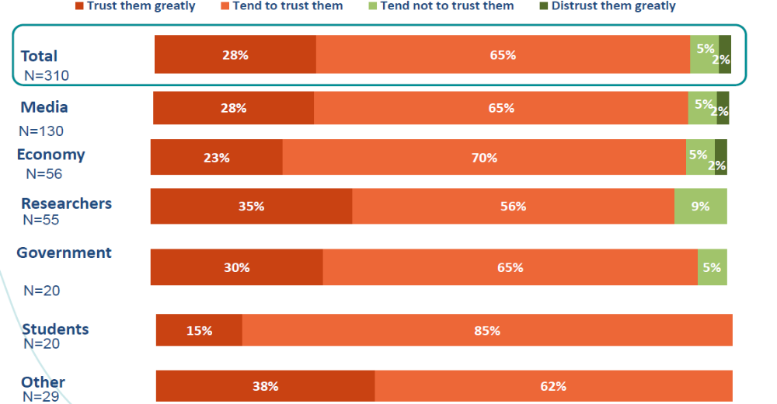

Base: Total N=310

- The biggest problem for CBS users is the way they can acquire statistical data.

Question: Please evaluate how much you agree or disagree with the following statements about CBS in general. Please use a scale from 1 to 5 where 1 means strongly disagree and 5 means strongly agree.
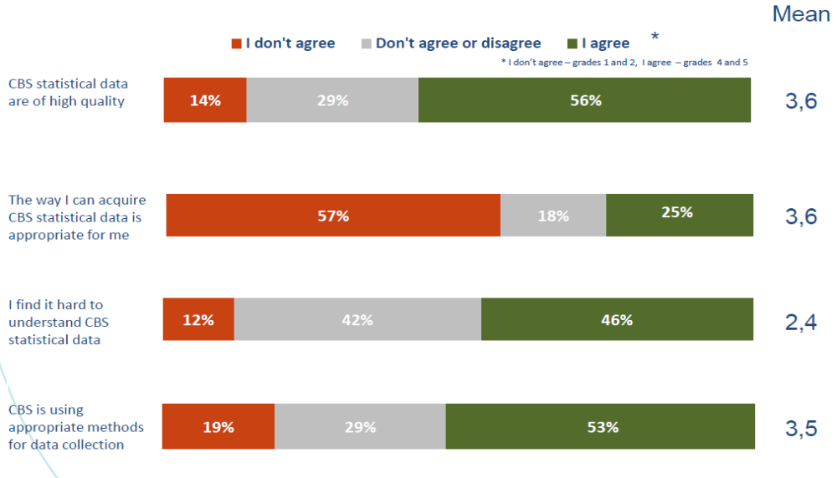
Base: Total N=310

- Part of users think that the data are published too late and that they do not cover their needs for statistical data about Croatia.

Question: Please evaluate how much you agree or disagree with following statements about CBS in general. Please use the scale from 1 to 5 where 1 means strongly disagree and 5 means strongly agree?
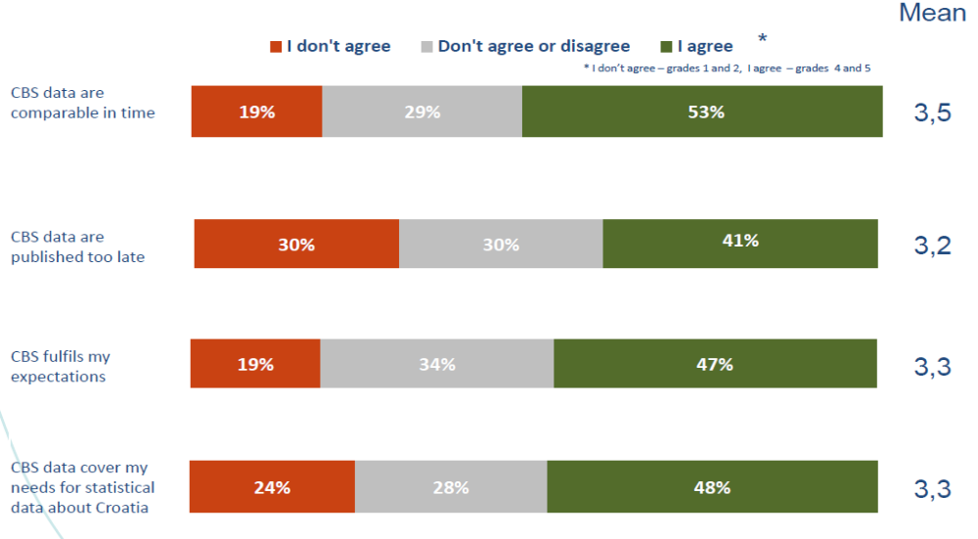
Base: Total N=310

Satisfaction with the CBS staff:

- The researchers most often visit CBS office while economy mostly send e-mail.

Question: Did you contact CBS in any of these ways in last year and a half?
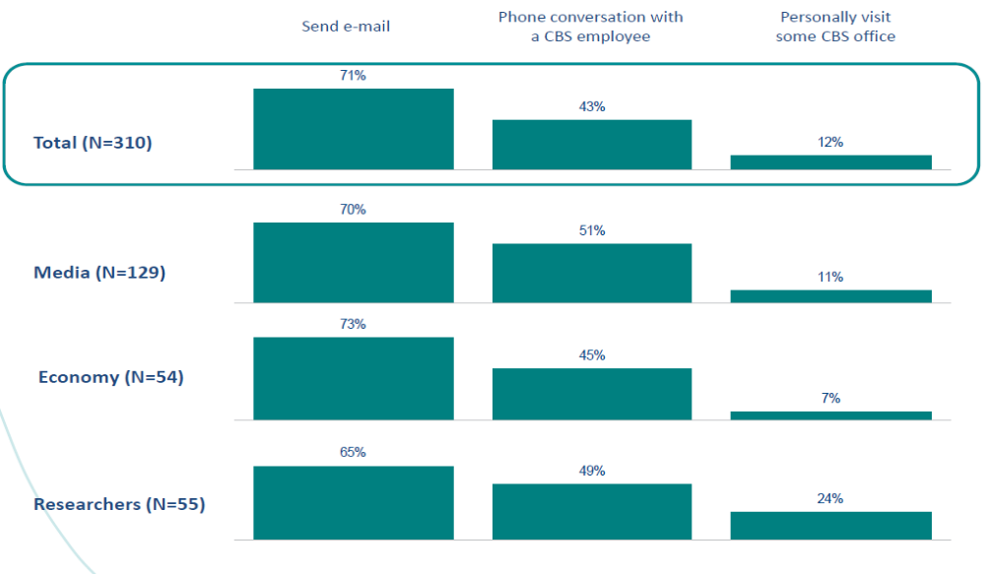
Base: Total N=310

- The students contact CBS almost only by e-mail and government bodies by mail and phone.

Question: Did you contact CBS in any of these ways in last year and a half?
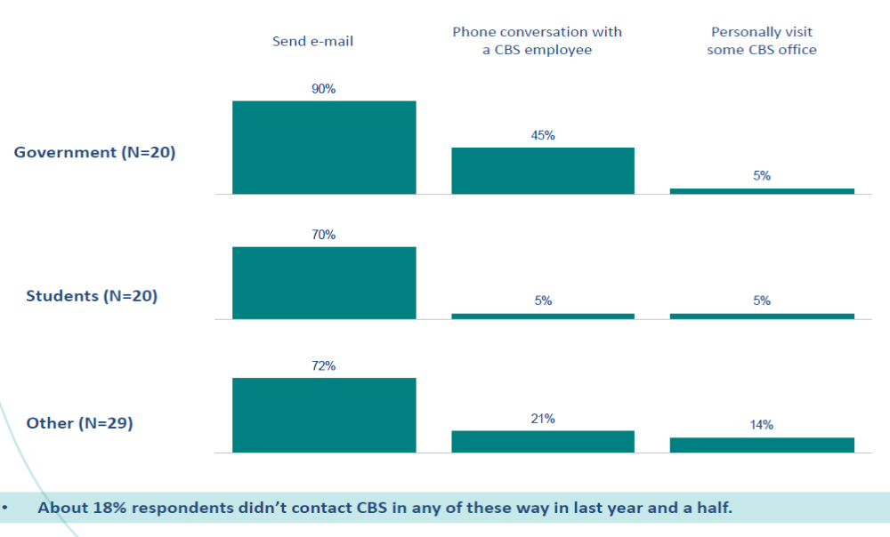
Base: Total N=310

- CBS employees are very well evaluated, especially as professional and willing to help – smaller problems users have with establishing contact and speed of response.

Question: Please think about your contact with CBS staff and evaluate how much you agree or disagree with following statements. Please use a scale from 1 to 5 where 1 means strongly disagree and 5 means strongly agree
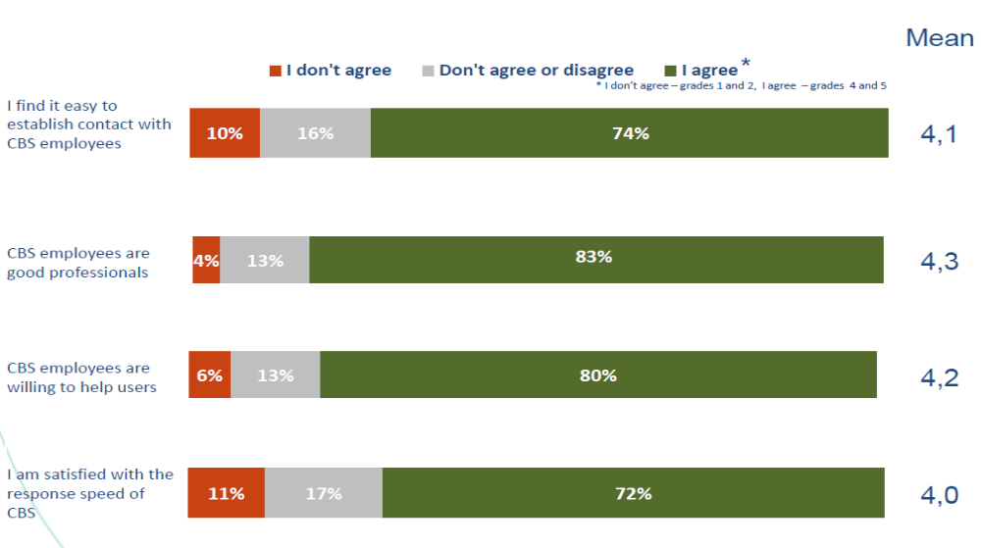
Database: The respondents who contact CBS in some given way, N=253

- CBS gets the best grades from students and other users and worst from media.

Question: How would you rate the overall quality of data and services?
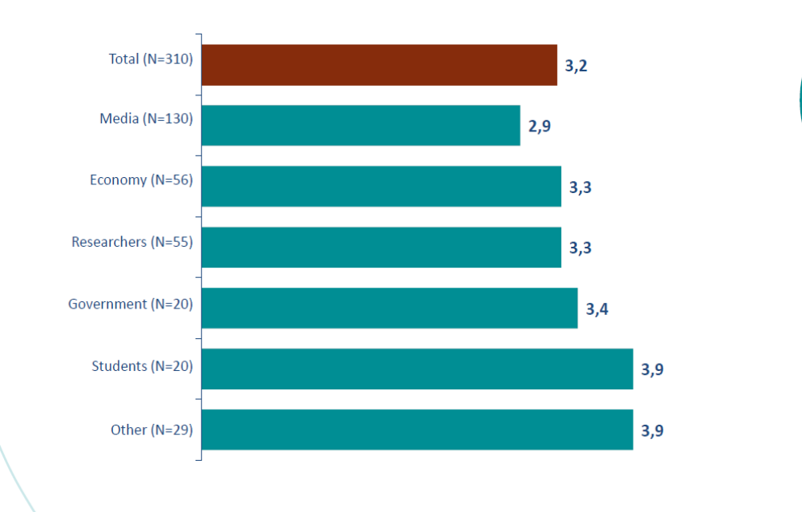
Base: Total N=310

- Users are most satisfied with the quality of answers and attentiveness and generally with the communication with CBS staff.

Question: What are you generally most satisfied with at CBS?

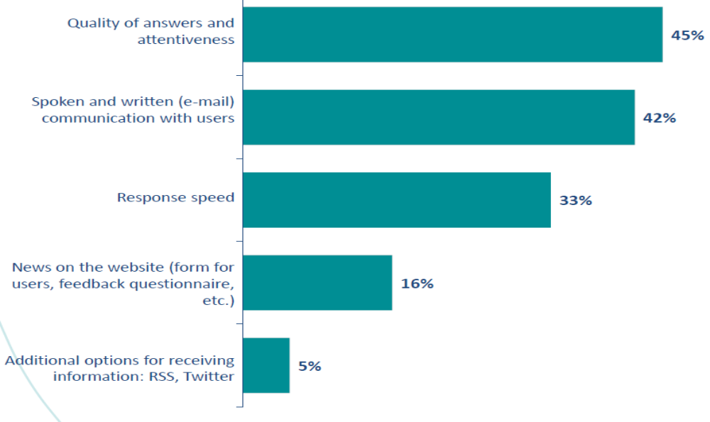
Base: Total N=310

- The biggest sources of dissatisfaction are insufficient databases, publication formats
and website.

Question: What are you most dissatisfied with at CBS?
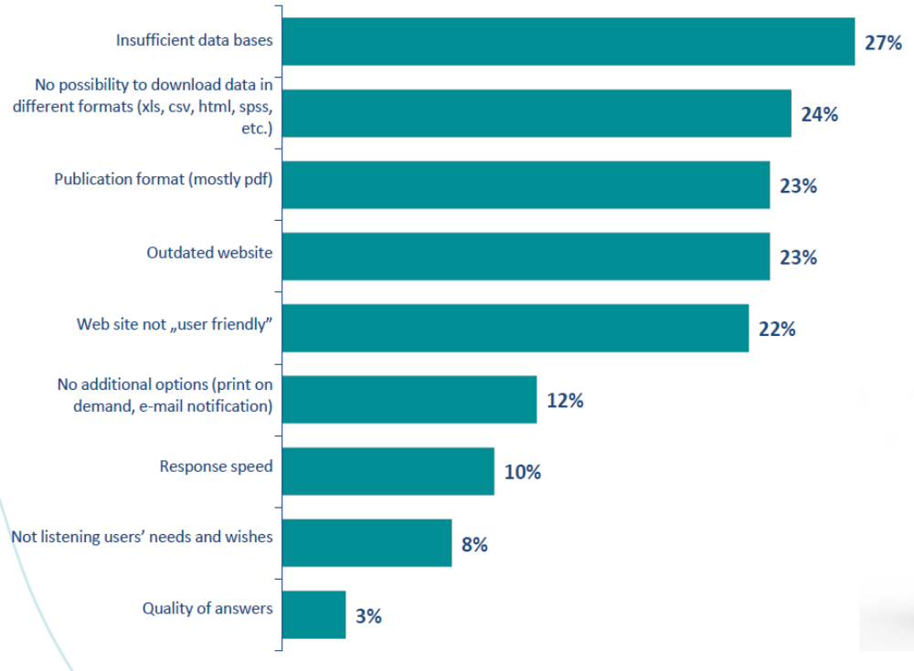
Base: Total N=310

ACTIVITIES
INDICATOR

Monitor regularly user satisfaction
Satisfied users

3. Reduce the response burden of respondents

As in all EU national statistical institutes as well as in the CBS, one of the leading priorities in the field of official statistics is to reduce the respondent burden. The CBS currently uses a limited number of administrative data in comparison with the existing sources, mainly because of difficulties in their regular and timely provision and because of large resources necessary for their processing for statistical purposes.

3.1 Increase the use of administrative data sources

Using administrative data sources for statistical purposes will reduce the expenditures of statistical production and the respondent burden, and will at the same time increase the accuracy of statistical products.
The CBS is continuously working on detecting and analysing new administrative sources with the aim to increase the use of administrative data for statistical purposes and so consequently the increase of statistical surveys based on administrative sources.

Having analysis of data collected through statistical surveys and examining the content and the structure of each administrative source, opportunities will be taken as they are identified for the use of administrative sources instead of data collection through statistical surveys and where necessary and appropriate methods of estimation and imputation will be used alongside these administrative data in their replacement of survey-data. The administrative data will be processed by using statistical methods for standardised statistical product. In that way the reporting burden of business entities and households will be reduced for statistical data collection and the budgetary funds of official statistics will be rationalised.

ACTIVITIES
INDICATOR
Increase the use of administrative sources for statistical purposes
Improve the cooperation with the data providers
Reduce the costs of statistical data production
Reduce response burden of the respondents

3.2 Increase the use of electronic questionnaires

The CBS is developing a new electronic system of data collection for questionnaires delivered to the reporting units – legal business entities and crafts – in the Republic of Croatia. Unlike the current system which is based on delivery of completed paper questionnaires only by ordinary mail, these questionnaires will enable reporting units to use an alternative way for the delivery of required data.

It has turned out that electronic questionnaires are interesting and simple to use for the reporting units, therefore it is believed that in the future this kind of delivery of the statistical data to CBS will become preferred way for the reporting units..

Due to the fact that the reporting units have accepted new statistical data collection method very well, the CBS intend to carry out the new statistical surveys by using electronic questionnaires, and progressively convert existing surveys to electronic questionnaires.

Electronic questionnaires are currently in use for statistical surveys from the area of industry while within the IPA 2009 project will be from the area of energy and trade and construction and services

ACTIVITIES
INDICATOR
Introduce the electronic questionnaires in more surveys
Simplify the handling with the questionnaires
Adjust statistical processes with new methods of data collection
Number of satisfied respondents with the new data collection method
Number of modernised statistical surveys

3.3 Burden the respondents equally

In order to achieve better quality of statistical data, a good communication with the respondents will be established as well as equal distribution of their workload during the year. The emphasis will be put on the respondent satisfaction as their satisfaction during the conduct of statistical surveys is an essential element of the quality of statistical processes and products.

In business statistics surveys it is planned to carry out and analyse possibilities of introducing coordinated sampling. The system of coordinated sampling is based on the total sample frame from which the samples are selected for all business statistics surveys. This system can provide a more equal sample distribution.

ACTIVITES
INDICATOR

Establish a system of equal respondent burden
Provide a system with the equal sample distribution using coordinated sample procedure

Increased number of satisfied respondents
Equal distribution of respondent burden

4. Effectiveness of statistical processes

4.1 Optimise processes

In order to optimise all statistical processes within the CBS, the template for describing and documenting processes according to the Generic Statistical Business Process Model- GSBPM was created.

The preparing model will be used during describing and documenting each statistical survey and determining its quality level. The template was prepared according to the above mentioned model – GSBPM and is intended for all activities carried out by producers of official statistics at national and international level. The GSBPM is adapted to the Croatian statistical system's needs and was designed as a model independent of data sources, so it can be used for describing and evaluating the quality of statistical surveys, censuses, administrative records and other non-statistical or combined data sources.

ACTIVITIES
INDICATOR

Implement template for describing and documenting every statistical survey and determining the quality level

Increase the number of completed templates for statistical surveys

4.2 Establish the planning system and the controlling instruments

The effective management of quality demands comprehensive, realistic and accurate instruments for planning processes and projects (management by objectives). The Strategic Plan for the period 2012 – 2016 define the general objective, specific objective of the program in the state budget, the performance indicator, way to achieve specific objectives, activities in the state budget and the indicators of results.

The risk register is defined which contains the recorded data about the identified risks and risk coordinators according to the organisational units.

As an important base for effective planning and the control is a comprehensive process-oriented system for the registration of human resources (working hours) in all statistical projects/fields was introduced as well as the new financial and accounting system. The annual budget and the four-year medium term planning is an integral part of the CBS quarterly and annual reports.

An independent Internal Audit unit is now established which conducts internal audits in the CBS, gives professional opinion and has an advisory role for improving CBS business operation, estimate systems, processes and the internal controlling system based on the risk management, carries out internal audits in accordance with the best professional practice and internal audit standards in line with the International standards on internal auditing and the Ethics Code of the Internal Auditors. It does tests, analyses and evaluates all business functions of the office, conducts audits on use of EU programmes and monitors possible irregularities in use of EU funds; carries out revision of statistical production processes in accordance with the European Statistics Code of Practice and gives recommendations for improving the quality of statistical processes and products; conducts individual internal audits and makes recommendation to the DG for achieving better efficiency and effectiveness. Also, it develops strategic and operational audit plans, performs special audits on director, monitors the implementation of recommendations from previous audits, prepares periodical and annual working reports and delivers to responsible institutions and persons in accordance with the current with the regulations, cooperates with the Internal audit and Financial Control organisational unit of the Ministry of Finance, which includes an obligation to provide strategic and annual plans and annual reports to the competent organisational unit of the Ministry of Finance, monitors and suggests continuous education of internal auditors in accordance with the International standards on Internal Audit. Internal Audit unit evaluates implementation of recommendations of the National Audit Office and carries out other tasks within the scope of the division. It ensures that every expense is justified by the real need and confirmed with the previous control.

ACTIVITIES
INDICATOR

Procedure of internal audit
Give expert opinion and advices
Estimate the system, processes and internal controlling system
Give recommendations for quality improvements of statistical process
Prepare periodical and annual reports on work
Take care that every expense is justified with the real need and confirmed by previous control
Improved CBS management
Improved the quality of statistical process
Responsible disposal of financial means

4.3 Optimise the project management

The systematic and comprehensive implementation of project management in the CBS has been established and also the raising of awareness regarding the importance of project management across the organisation.

The Independent Service for the project implementation is the CBS Project Implementation Unit that carries out activities related to the direct implementation of project financed from EU funds i.e. the projects financed by loans and grants from other foreign sources and in the coordination with the Central Finance and Contracting Agency for EU projects (hereinafter: the Agency), the operational programmes and the authorities responsible for strategy and the coordination of EU funds use, activities related to the preparation and drafting project documentation, participation in the procurement procedures and drafting contracts for projects financed from the EU funds and international organisations assets, including grants in cooperation with the CBS professional internal organisational units.

It coordinates business activities connected with the administrative financial monitoring of the project implementation that are financed through EU funds. The organisational unit cooperates with the organisational units in charge for planning and budget execution, and it also takes care that every expenditure is approved with the real need and confirmed with the previous control.

Creating informal project teams within the CBS is a continuous process. The members of the informal teams are experts from different statistical areas. Their task is to review all new projects with the aim of providing recommendations on the CBS management level taking into account the methodological guidelines, meaningfulness and available resources.

ACTIVITIES
INDICATOR

Prepare project documentation
Monitor the realisation of approved projects
Qualified project team of statisticians within the CBS
Successful use of EU funds

5. Vocational guidance of staff

5.1 Educate staff continuously

All civil servants, among which are also statisticians, are obliged to permanently improve their professional abilities and skills, getting new knowledge and skills and improving them continuously, in order to better carry out their assignments, to be effective, in accordance with the new policy demands, and through this also achieves in CBS larger job satisfaction and ultimately larger organizational efficiency.

Based on the Article 4 of the Regulation on forms, methods and conditions of the civil servants training (OG. 10/07.), the Ministry of Administration conducts the assessment of civil servants training needs. All state bodies submit their proposals on the training programs for civil servants to the Ministry of Administration on May 31 of the current year for the next year.

Since the qualified and motivated staff are the major participants in the statistical production processes CBS continuously invests in the staff education. Competent staff participate in meetings and conferences, and represent the opinion of the Republic of Croatia on certain statistical issues.

The ESTP courses are a big challenge and one of the ways to enable establishment of comparable statistics at European and international level. The courses are targeted on the harmonised European concepts and the legislation as well as on the practical implementation on the national level. The purpose of the ESTP courses is to provide the European statisticians opportunity to participate on international education courses, workshops and seminars of the postgraduate level.

Regarding the education organised by the National School of Public Administration, it should be mentioned that the activity of the school is the professional development and training of civil servants as well as chosen officials in local and regional self-government in cooperation with the national association of local and regional self-government and legal persons with the public authorities, with the aim of continuous raising the quality level of their knowledge, skills and abilities to form a professional, effective and efficient public sector that will provide timely and high-quality public services in accordance with the generally accepted best standards.

Besides the existing educational programme courses are organised within the CBS. This is considered of special importance, because some statistical skills can be gained only within this institution and nowhere else.

ACTIVITIES
INDICATOR
Competent staff
Increased number of internal education activities held
Participate on international and national expert working groups and conferences
Establish a system of internal staff education

5.2 Monitor the satisfaction level of CBS staff

In order to increase the motivation and satisfaction of the staff, it is necessary to collect opinions and problems of the staff in regular intervals.

How to increase the satisfaction at work

CBS is aware that the sense of satisfaction and happiness at work is something that every individual will define differently. The conventional thought is that the precondition for job satisfaction is the height of the salary of the employee, but it is also known that the salary is not only the determining factor for satisfaction.

In order to influence the motivation of employees, it is necessary to take into account the causes of its decline and as far as possible remove them, or at least alleviate their effect. First of all, this is the lack of communication within and between CBS organisational units, leading to a gloomy atmosphere, negative attitude, work exhaustion and stress.

The means to increase satisfaction at work could be as follows:

I. Communication should be open

The CBS is working on improving communication skills among employees every day. All employees are aware that each task needs to be addressed professionally and impartially and that they need to work on the motto that there is no bad day because all CBS employees are professionals.
II. Democratic management style

Choosing a good manager is for sure a key element of the CBS business success. A system which enables high-quality and smooth operation was introduced.

III. Good interpersonal relationship and cooperation

Daily informal gatherings during the daily breaks have a beneficial effect on the creation of togetherness among employees, and this is particularly important in the CBS where teamwork is appreciated.

IV. Clear expectation from staff

The expectation should be clear, the objectives concrete, achievable and realistic and well-defined in terms of measurability, deadlines and assignments, so that they represent a challenge for the staff who should receive specific feedback on their work, both positive and negative

V. Illustration of performance influence on the individual

The CBS directors take care that staff who deserve praise, at least get verbal praise and when it is possible to attend some additional education either at home or abroad.

VI. Demonstration of trust

The CBS directors will take care that the employees do not delegate tasks that are below their capacity except in cases when it is inevitable. The special emphasis will be on the staff quality and that the employees’ skills are not underestimated, because without this the staff will work less and may be forced to find another working environment. It will be taken in account that it is necessary to give the opportunity for learning and advancement to all.

Every one of us is satisfied with the work if it has sense and if one can be proud of, if it fits our abilities and interests. On the other hand, there is no salary that will make employees satisfied, if it is not clear what is expected from them, if they do not know whether they are working well or not, and if they are working the same job for years without any possibilities of getting any promotion or to learn something new.

The CBS tries to increase the satisfaction and the engagement of employees with different means. Unsatisfied employees are interested to leave the work and in that particular case the sources invested in that employee earlier will be used irrationally and perhaps unprofessionally used. Therefore, in order that the CBS functions optimally it is necessary to control and maintain staff satisfaction, because the working performance in the whole rests on the effective use of human resources.

ACTIVITIES
INDICATOR

Continuously carry out staff satisfaction surveys
Satisfied staff

In that sense the first staff satisfaction survey was carried out within the PHARE 2005.
The results of that survey are as follows:

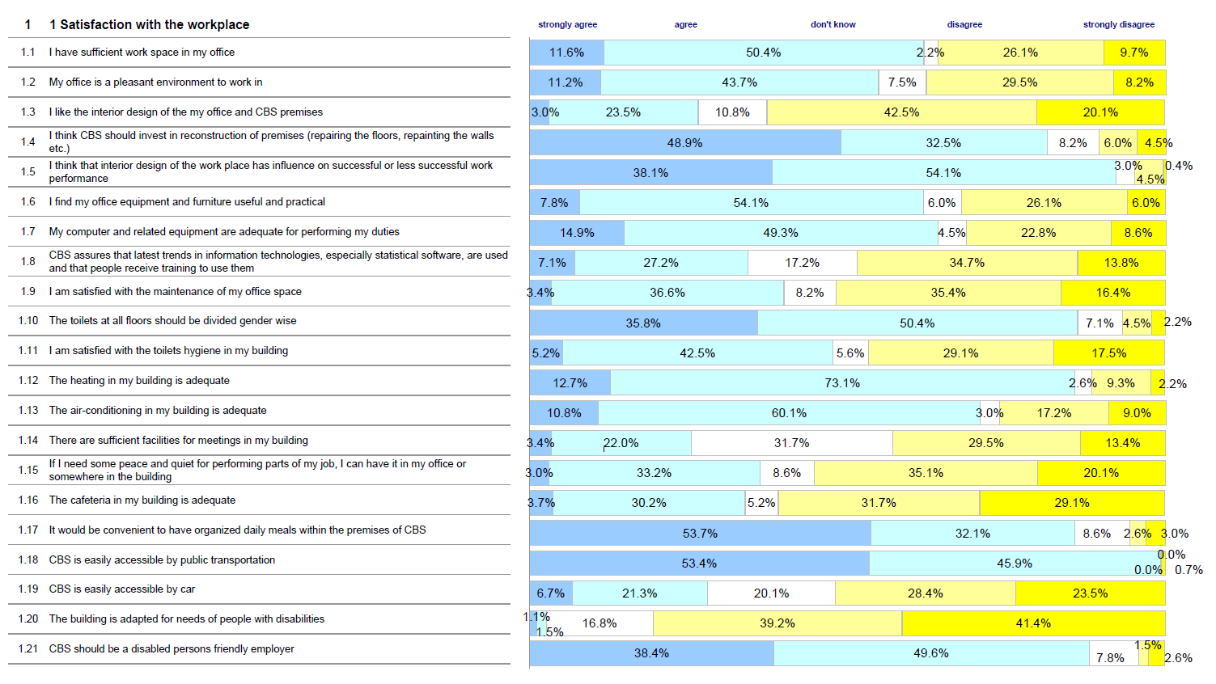

The feedback information collected through this survey were the starting point for introducing further qualitative improvements in the CBS management of its human resources and their vocational guidance.

5.3 Improve communication within the staff on all levels

Communication is one of the main functions of the CBS and its importance cannot be stressed enough. It is a process of transmitting information, ideas, thoughts, opinions and plans between various organisational units, considering it horizontally and vertically. The good relationships among employees are not possible without communication, so a good and effective communication is an integral part of human relationships and so the successful management of the statistical processes within the CBS.

For the CBS managers the most important point is to know how to interact and communicate with the employees, because the many management problems happen because of the lack of proper communication. The possibility of the wrong understanding and presenting things unclearly can be minimised in cases where the good communicating skills exist.

Communication is the basic tool for motivation that can improve moral of CBS staff. Inappropriate or inadequate communication among employees or between them and CBS management can be a main cause of conflict and low morale. Within the CBS business system should be introduced guidance on good communication that will explain to employees, so the employees could work better and with more motivation on what they should do, how will they perform their work and what should be done

ACTIVITIES
INDICATOR

Continuously improve communication on all levels
Successful CBS business
LITERATURE

1. | Kodeks prakse europske statistike: www.dzs.hr rubrika ESDS europski statistički sustav  European Code of Practice: www.dzs.hr subject ESD European statistical System
2. | Jednostavan pregled provedbe Kodeksa prakse europske statistike u Hrvatskoj  LightPeerReview of the ImplementationoftheEuropeanStatisticsCodeofPracticein Croatia
2. | Eurostat internetske stranice o kvaliteti: http://epp.eurostat.ec.europa.eu/portal/page/portal/quality/introduction/  Eutostat Internet pages about quality:  http://epp.eurostat.ec.europa.eu/portal/page/portal/quality/introduction/
3. | ESS Deklaracija o kvaliteti  ESS Quality Declaration http://epp.eurostat.ec.europa.eu/cache/ITY_PUBLIC/QUALDEC/EN/QUALDEC-EN.PDF
4. | ESS definicija kvalitete  ESS Quality Definition http://epp.eurostat.ec.europa.eu/portal/page/portal/quality/documents/ess%20quality%20 definition.pdf
5. | ESS Pojmovnik o kvaliteti  ESS Glossary on quality http://epp.eurostat.ec.europa.eu/portal/page/portal/quality/documents/ESS%20Quality%20 Glossary%202010.pdf
6. | Strateški plan Državnog zavoda za statistiku 2014. – 2016: www.dzs.hr rubrika Pravni temelji  Strategic plan of CBS 2014 – 2016 – www.dzs.hr subject Legal base
7. | Strategija razvitka službene statistike Republike Hrvatske 2013. – 2022. : www.dzs.hr rubrika Pravni temelji  Strategy of official statistics development of the Republic of Croatia 2013 – 2022: www.dzs.hr subject Legal base
7. | Strategija upravljanja rizicima, Zavod, December 2008.  Strategy on risk management, CBS, December 2008
8. | Strategija diseminacije, Zavod, ožujak 2010  Dissemination strategy, CBS, March 2010
9. | Zakon o službenoj statistici NN, br. 103/03., 75/09. i 59/12.  Act on official statistics OG, Nos. 103/03, 75/09 and 59/12
10. | Pravilnik o načinu zaštite statističkih podataka, Klasa: 950-01/04-01/16,  Urbroj: 555-11-01-04-1, od 2. srpnja 2004.  Ordinary Act on statistical data protection, Ref. 950-01/04-01/16,  555-11-01-04-1 of 2 July 2004
11. | Pravilnik o pristupu povjerljivim statističkim podacima Obavijesti,  XXXVII br. 4 od 18. srpnja 2013.  Ordinary Act on acess towards confidential statistical dana Notices,  XXXVII No. 4 of 18. July 2013.
12. | Pravilnik o uvjetima i načinu korištenja povjerljivih statističkih podataka za znanstvene svrhe, NN, br. 137/13.  Ordinary Act on conditions and using manner of confidential statistical data for scientific purposes, OG, No. 137/13.
13. | Povelja unutarnjih revizora, Klasa 043-01/13-01/14,  Urbroj: 555-04-01-13-1 od 17. srpnja 2013.  The Charter of Internal Auditors, Class 043-01/13-01/14, Reg 555-04-01-13-1 of 17 July 2013.
14. | Uredba o unutarnjem ustrojstvu Državnog zavoda za statistiku NN, br. 80/12.  Regulation on the internal organisation of the CBS OG. 80/12.

TOTAL QUALITY MANAGEMENT (TQM) - ACTIVITIES, INDICATORS AND DEAD LINES

 |  | ACTIVITIES | INDICATOR | DEAD LINE
1.1 | Monitor quality in statistics | - Produce coherent and consistent data  - Take care of coherence and comparability  - Establish harmonised quality monitoring for statistical processes and products  - Offer users relevant metadata  - Establish organisational unit for quality monitoring | - Statistical products of high quality | December 2017  December 2017  December 2017  December 2015  September 2015
1.2 | Report on quality | - Prepare quality reports by respecting  six fundamental criteria: (relevance, accuracy, timeliness and punctuality, accessibility and clarity, comparability and coherence)  - Prepare quality guidelines | - Quality reports  - Quality guidelines | December 2017  December 2017
1.3 | Introduce pilot phases for quality testing | - Choose six pilot surveys and on them test concepts, definitions, etc.  - Determine individual quality criteria  - Test difficulties in practical implementation  - Collect information on respondent burden and on necessary resources  - Verify whether the Eurostat requirements can be completed  - Determine gaps and criteria that were  not covered  - Find out which improvements are necessary to be included. | - Introduced survey in accordance with the TQM  - Publish first of the TQM based QRs on the web site | December 2017  December 2015  December 2015  December 2015  December 2015  December 2015  December 2015
2.1 | Implement modern dissemination tools in accordance with the user needs | - Offer users tools that will enable them  by selecting the parameters to define  the quantity and format of presenting statistical data | - Increase the number of statistical surveys in the Integrated Statistical Information System (ISIS) i.e. the number of surveys whose parameters can be entered | December 2016

TOTAL QUALITY MANAGEMENT (TQM) - ACTIVITIES, INDICATORS AND DEAD LINES

(continued)
 |  | ACTIVITIES | INDICATOR | DEAD LINE
2.2 | Develop relationships with users (regular monitoring of user needs | - Held education in implemented methodologies and correct data interpretation  - Create base for further development of relationship with the users  - Increase awareness on importance of including users in the official statistics production and Open Days  - Increase number of publications in media  - Inform publicity with the CBS scope and the results  - Introduce continuous user satisfaction survey | - Increased number of held press education and conferences  - Increased number of held Open Days  - Increased number of publications in media (pressclipping)  - Increased number of information on user needs | December 2015  December 2015  December 2015  December 2015  December 2015  December 2016
2.3 | Establish metadata management system | - Continuous upgrade of central metadata through application development for many purposes | - Increased number of satisfied users with the application functionalities in percentage | December 2015
2.4 | Establish data protection on data confidentiality | - Protect confidential data that refer to the individual statistical unit | - Reporting units are providing confidential data because they trust CBS | December 2015
2.5 | User satisfaction | - Monitor regularly user satisfaction | - Satisfied users | Continuously
3.1 | Increase the use of administrative data sources | - Increase the use of administrative sources for statistical purposes  - Improve the cooperation with the data providers | - Reduce the costs of statistical data production and response burden of the respondents | Continuously  Continuously

TOTAL QUALITY MANAGEMENT (TQM) - ACTIVITIES, INDICATORS AND DEAD LINES

(continued)
 |  | ACTIVITIES | INDICATOR | DEAD LINE
3.2 | Increase the use of electronic questionnaires | - Introduce the electronic questionnaires in more surveys  - Simplify the handling with the questionnaires  - Adjust statistical processes with the new methods of data collection | - Number of satisfied respondents with the new data collection method  - Number of modernised statistical surveys | December 2017  December 2017  December 2017
3.3 | Burden the respondents equally | - Establish a system of equal respondent burden  - Provide a system with the equal sample distribution using coordinated sample procedure | - Increased number of satisfied respondents  - Equal distribution of respondent burden | Continuously  Continuously
4.1 | Optimise processes | - Implement template for describing and documenting every statistical survey and determining the quality level | - Increase the number of completed templates for statistical surveys | Continuously
4.2 | Establish the planning system and the controlling instruments | - Procedure of internal audit  - Give expert opinion and advices  - Estimate the system, processes  and internal controlling system  - Give recommendations for quality improvements of statistical process  - Prepare periodical and annual reports  on work  - Take care that every expense is justified with the real need and confirmed by previous control. | - Improved CBS management  - Improved the quality of statistical process  - Responsible disposal of financial means | Continuously  Continuously  Continuously  Continuously  Continuously  Continuously
4.3 | Optimise the project management | - Prepare project documentation  - Monitor the realisation of the approved projects | - Qualified project team  of statisticians within  the CBS  - Successful use of EU funds | Continuously  Continuously

TOTAL QUALITY MANAGEMENT (TQM) - ACTIVITIES, INDICATORS AND DEAD LINES

(continued)
 |  | ACTIVITIES | INDICATOR | DEAD LINE
5.1 | Educate staff continuously | - Participate on international and national expert working groups and conferences  - Establish a system of internal staff education | - Competent staff  - Increased number of hold internal education | Continuously  December 2017
5.2 | Monitor the satisfaction level of CBS staff | - Continuously carry out staff satisfaction surveys | - Satisfied staff | Continuously
5.3 | Improve communication within the staff on all level | - Continuously improve communication on all levels | - Successful CBS business | Continuously

PeerReview is an control instrument of the national statistical system applied in the European statistical system. This instrument assesses the application of the Code of Practice of European statistics. The purpose of the Code of practice, i.e. its application, is to increase confidence in the independence, integrity and accountability of the national statistical authorities and Eurostat and the credibility and quality of the statistics they produce and disseminate. Furthermore, the purpose of the Code is to promote the application of best international statistical principles, methods and practices of all producers of European statistics.

