The Unu-Water Exercise

A Step-by-Step
Introduction to
Environmental –Economic Accounts
for Water
(SEEA-Water)

Workbook

13 June 2014
Rev 8
(Translation was done with version 2)

Module I: Basic understanding of the water cycle in the economy

Template for diagram of water flows in the economy

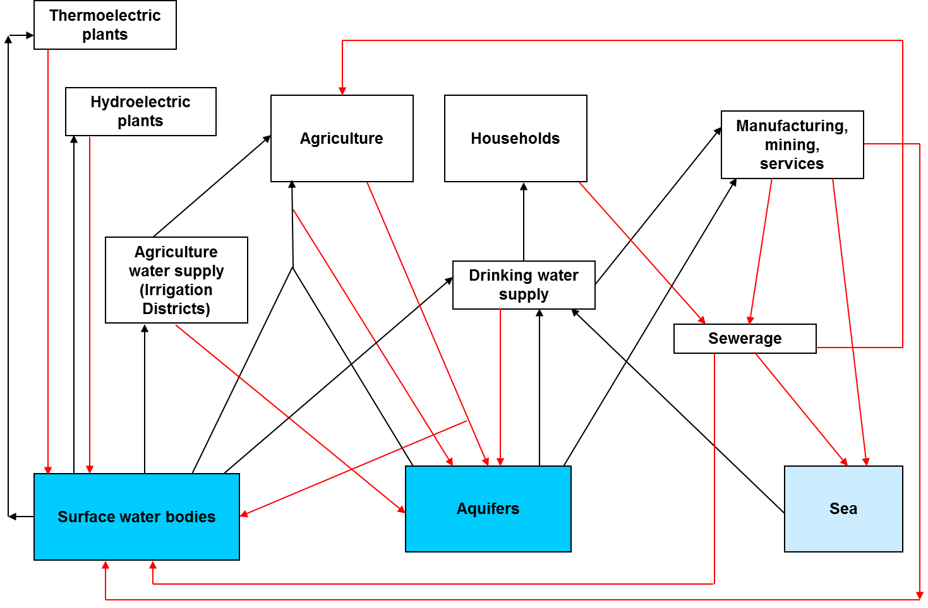
Template for list of data items

IRWS code | Data item
E.1.1  (example) | Abstraction of surface water  (example)

\
Template for activities and ISIC codes

Activity | ISIC code
Agriculture, forestry and fishing  (example) | 01 to 03  (example)

Module II: Basic understanding of the natural water cycle

Template for diagram of water flows in the natural water cycle

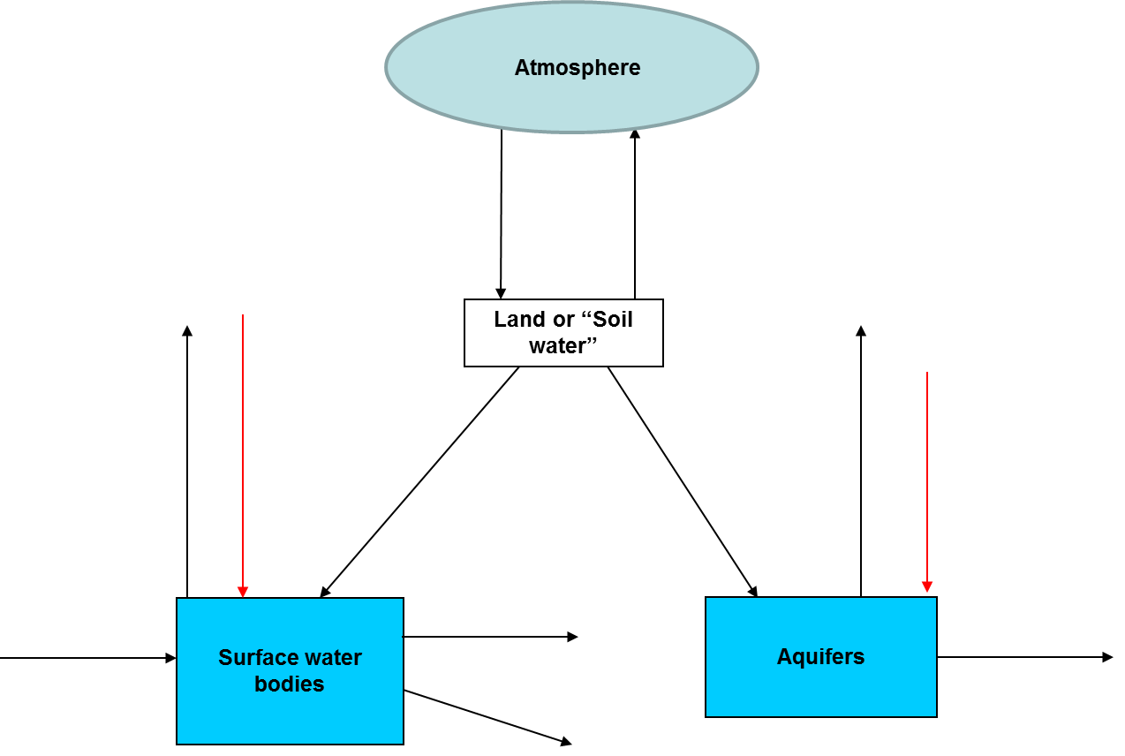

Template for list of data items

IRWS code | Data item
B.1  (example) | Precipitation  (example)

Module III: Monetary supply and use tables

Template for supply table (at basic prices)

Template for use table (at basic prices)

Module IV: Including taxes and trade margins

Template for conversion of supply table at basic prices to purchasers’ prices

The use table at purchasers’ prices is provided:

Module V: Monetary information related to water supply and sewerage

Template for the sequence of economic accounts for the water supply industry

Template for the sequence of economic accounts for the sewerage industry
Template for changes in net worth (water supply)

Template for changes in net worth (sewerage)

Module VI: Physical supply, use, and asset tables

Template for the physical supply table

Template for the physical use table

Template for the asset account

Template for the physical sequence of accounts

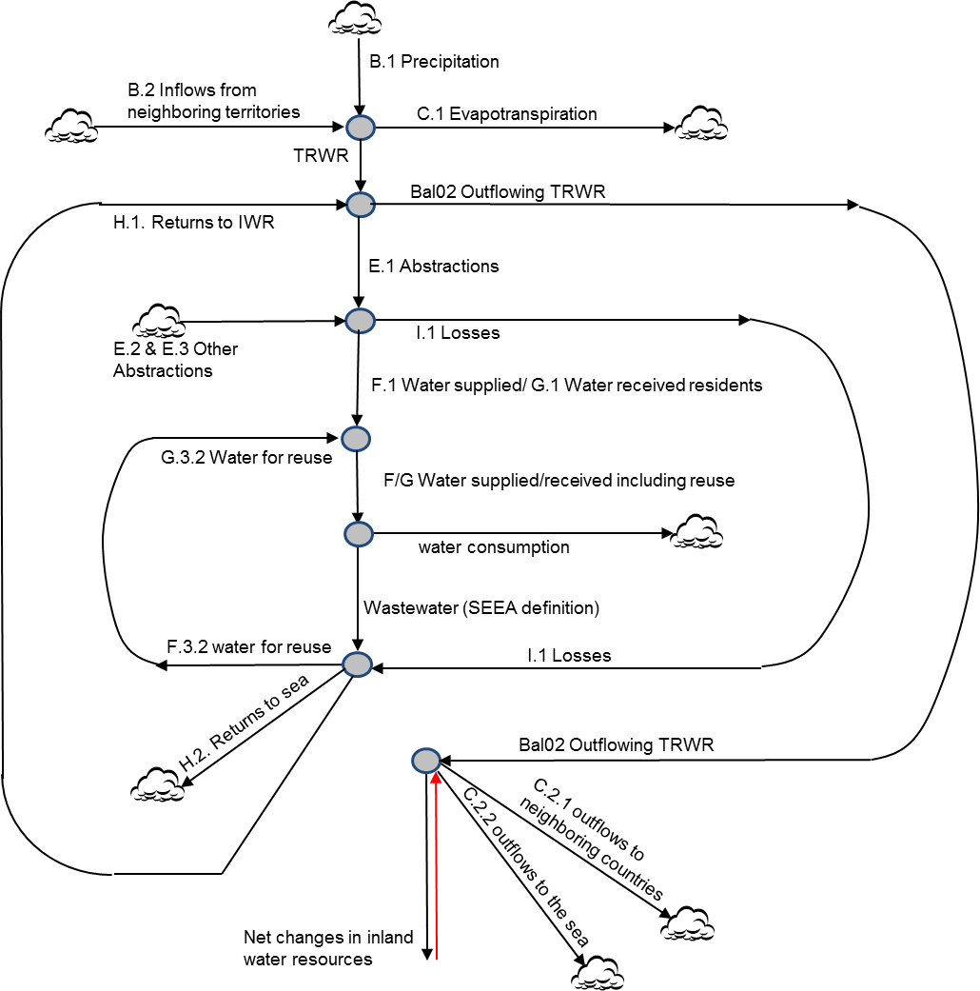

Module VII: Waterborne pollution

Template for diagram of pollution flows

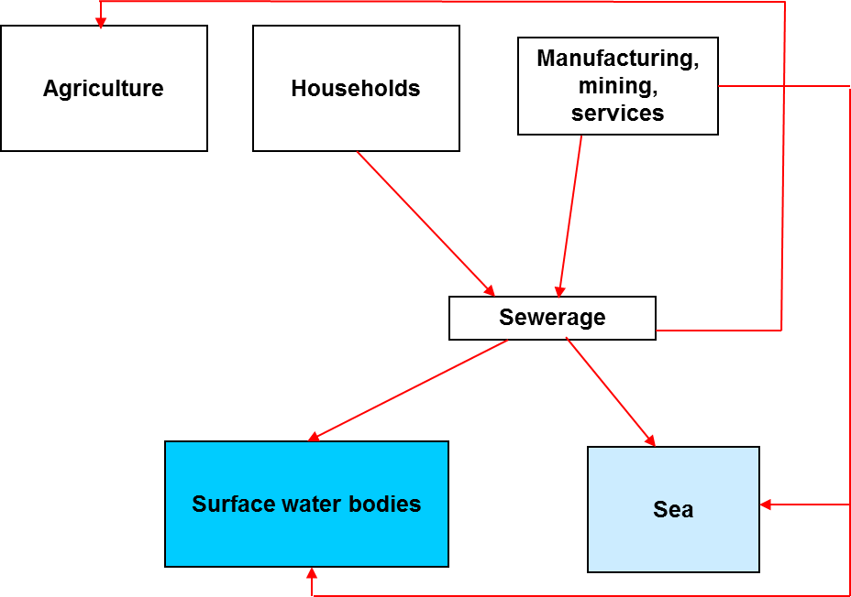

Physical supply table for pollution releases and emissions (thousand tons per year)

Physical use table for pollution releases and emissions (thousand tons per year)

Module VIII: Basic Indicators

Template for combining physical and monetary information

Module IX: Dynamic behavior

Template for recording time series

Module X: Adding Details to the Accounts

Template for the diagram
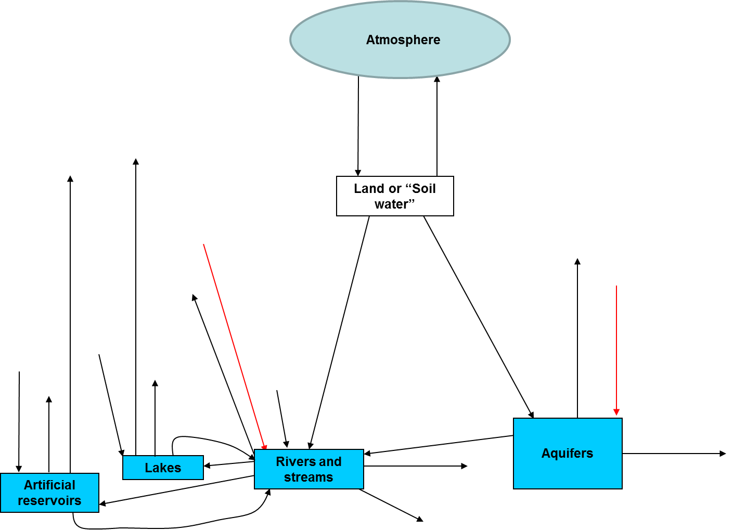

Template for the asset account table

