The Unu-Water Exercise

A Step-by-Step
Introduction to
Environmental –Economic Accounts
for Water
(SEEA-Water)

20 June 2014
Rev 31
(translations were based on revision 24)
Presentation

This example provides a collection of exercises intended to assist statisticians and water experts in the use of standardized statistical tools for developing comprehensive, consistent and comparable policy relevant information about water. The example is a complement to the Guidelines for the Collection and Compilation of Water Accounts and Statistics developed by the UN Statistics Division.

The exercises gradually add more elements and details to be considered for understanding the water problems in the fictitious country of the example. Throughout the exercises the reader will be able to appreciate the value of the statistical tools for integrating complex sets of apparently unrelated data.

Acknowledgements

This example has been designed by UNDESA-Statistics Division. Throughout the design and revision process, the following people have participated: Alessandra Alfieri, Apolonio Basilio, Karima Bensouda, Ashraf Dweikat, Raúl Figueroa, Federico González-Medrano, Cor Graveland, Fabio Herrera-Ocampo, Marco A. Jaubert-Vincenzi, Ivo Havinga, Laura Johnson, Mark Lound, Omar Malik, Salvador Marconi, Ricardo Martinez-Lagunes, Michael Nagy, Marco Neves, Allan Ramírez, Leila Rohd-Thomsen, Gulab Singh, Anand Sookun, Francois Soulard, Kristina Taboulchanas, Sokol Vako, Michael Vardon, Moshe Yanai.
Unu: the country

Unu is a country located somewhere far and away. The full name of Unu is Unupacha, which in the local language means land of water. The name is not due to the abundance of water in the country, but rather because water is considered very important for the inhabitants of Unu.

Unu is a relatively small country. It has a total land area of 16 000 km² and a population of 6.25 million inhabitants. The economy of Unu is well diversified. Agricultural, livestock and forestry activities account for approximately 17% of the Gross Domestic Product (GDP), and employs 25% of the economically active population. Manufacturing accounts for approximately 23% of GDP, and employs 13% of the active population.

In terms of water, the country enjoys a fair amount of rainfall, 800 mm on average per year. Furthermore, 1 000 million cubic meters of water per year flow from the neighboring upstream country to Unu. For the purposes of water management, the country is divided into four water management regions as shown in the figure below. Only one region has access to the sea. The country only has a coastal line of 800 km. There are pollution problems, especially in the Eastern region, due mainly to the fact that not all wastewater collected in sewers is properly treated before discharging it to the rivers and streams of Unu.

Water is abstracted from the aquifers and surface water bodies to irrigate 465 000 ha of corn and sugarcane crops, to provide drinking water to the population, for use in the different industries, as well as for cooling of thermoelectric power plants. There is one desalination plant in the coastal region that abstracts water from the sea to complement the abstractions of inland water resources used for drinking water supply. In addition, several “run-of-the-river” hydroelectric plants turbinate the water of the rivers to produce electricity. 86% of the population is connected to the drinking water supply network, and 75% to the sewers.

In the past five years, a drought has raised serious concerns in the Government of Unu. Several cities of the country have experienced water shortages. Farmers have seen the productivity of their fields drop dramatically, due to lack of water for irrigation in the most critical weeks of the year. Besides, the government wants to give universal access to water and sanitation to the inhabitants of Unu, which will require investments to expand the water supply and sewerage networks, as well as additional volumes of water from the aquifers and surface water bodies.

The Ministry of Water Resources (UMWR), the Meteorological Office (MeteoU), and the Central Bureau of Statistics (CBSU), have been given the mandate to establish a water information system that will help the government in the design and evaluation of the new water policies that the government will put in place in order to secure sustainable water for the country.

UMWR, MeteoU, and CBSU have created a working group that will design the new water information system based on water accounting and statistical standards. Each agency is responsible for the quality of the data in the area of their competence.

The following exercises show the different sets of information analyzed by the working group in order to create the new information system, using a modular approach of increasing complexity. Additional information will be provided as needed.

Map of Unupacha showing the four water management regions

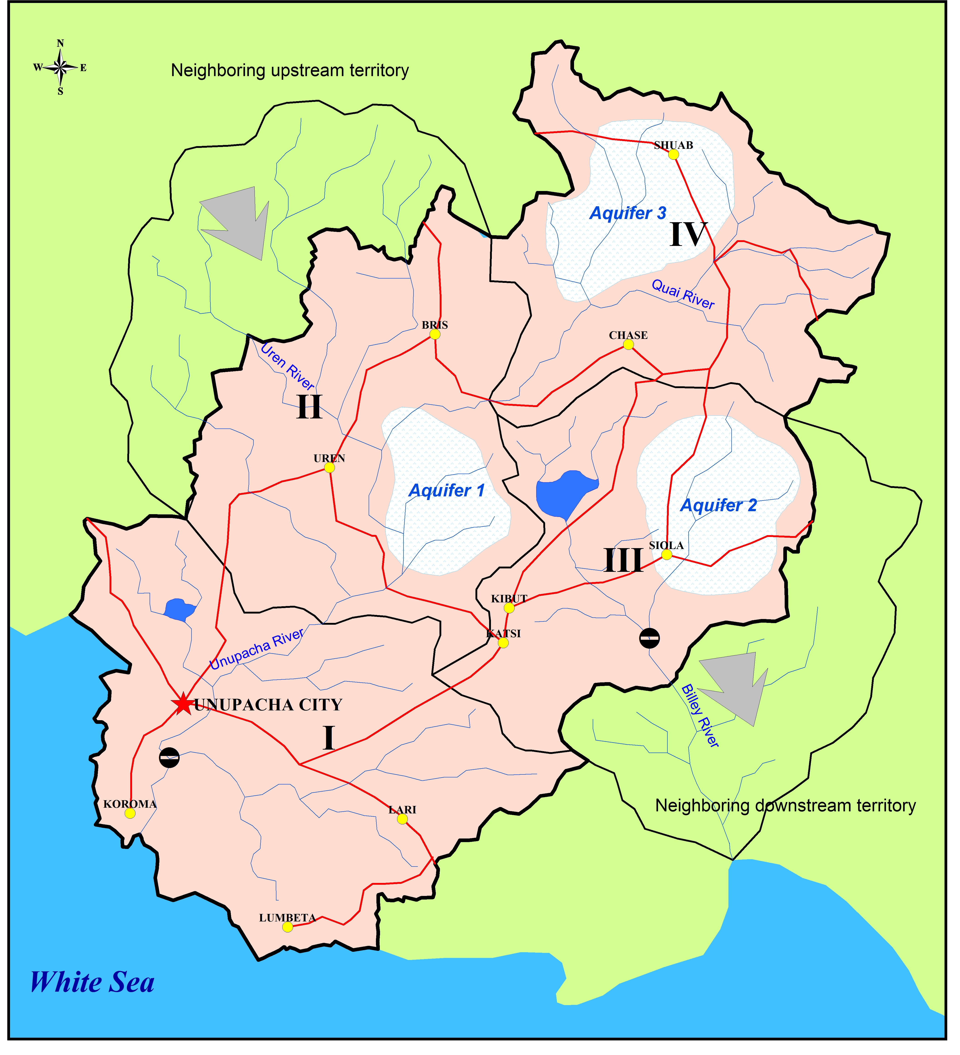

Module I: Basic understanding of the water cycle in the economy

The starting point will be the water cycle in the economy, which will allow us to determine how much water is abstracted from the environment, and how much water returns to the environment. With this information, in the next module, a more complete understanding of the water cycle will be sought.

It is estimated that the irrigation districts, which supply water to most of the farms, abstract 1 436 million cubic meters of water per year from the rivers, lakes and artificial reservoirs of Unu. About 22% of the water abstracted is lost in the canals that convey water to the fields.

There are also independent farmers that abstract their own water. The abstraction from surface waters by independent farmers is estimated to be 345 million cubic meters per year (hm³/year), and the abstraction of groundwater is 155 hm³/year. About 10% of the total water abstracted is lost before reaching the fields. Some fields are irrigated with 40 hm³/year of treated wastewater collected in the sewers of Unu.

Water utilities abstract 420 hm³/year of surface water and 200 hm³/year of groundwater to supply the cities of Unu with drinking water. Water utilities also desalinate 39 hm³/year of sea water to complement the abstractions of surface and groundwater. It is estimated that 190 hm³/year of water are lost due to leaks in the water supply network. It is estimated that 350 hm³/year of water are delivered to households and the rest is delivered to the different users connected to the network.

The businesses that are not connected to the water supply network have their own wells, which abstract about 83 hm³/year of groundwater.

There are thermoelectric plants in Unu that abstract 650 hm³/year of surface water for cooling. There are also hydroelectric plants that turbinate 19 600 hm³/year of water.

NOTE: 1 hm³ = 1 million cubic meters = 1 gigaliter = 1 GL.

Exercises

Refer to Chapter 3, section II of the Guidelines for details on how to approach the exercises.
- Review the following standard concepts from the System of Environmental Accounts Central Framework (SEEA-CF): Abstraction, Final Water Use, and Return Flows of Water.
- Make a diagram of all the interconnected flows of water with the information provided. Use the template provided.
- Identify the data items provided according to the data item codes of the IRWS (Annex I).
- Identify the industrial activities according to the ISIC standard revision 4.

Stretch Your Thinking

- Can you provide quantitative estimates of the information that is not provided and that is necessary to quantify all the flows of water, such as, water discharged to the sewers and returns to inland water resources? You can use coefficients to estimate the final water use (also known as water consumption).

Please stop and check your solutions at this point. Answers to question 5 require assumptions which will feed through into the rest of the exercise.

Module II: Basic understanding of the natural water cycle

According to MeteoU, the average precipitation in Unu is 800 mm/year, which in volume is equivalent to 12 800 million cubic meters of water per year (hm³/year). This is the result of multiplying the average precipitation by the total area of the country (800 mm/year x 16 000 km2 x 1/1 000 hm³/km²/mm). UMWR estimates that 20% of the precipitation becomes surface runoff and 5% infiltrates to the aquifers, the rest evaporates or is transpired by vegetation. This means that the total volume of evapotranspiration in the country is about 75% of the volume of precipitation.

There is also a transboundary river that brings 1 000 hm³/year of surface water to Unu from upstream territories. Another transboundary river flows from Unu to downstream countries taking 700 hm³/yr.

Exercises

Refer to Chapter 3, section I of the Guidelines for details on how to approach the exercises.
- Make a diagram that shows all the interconnected flows of water entering and leaving Unu, with the information provided. Use the template provided.
- Identify the data items provided according to the data item codes of the IRWS (annex I).

Module III: Monetary supply and use tables

The Central Bureau of Statistics of Unu (CBSU) collects monetary information from the different industries in Unu. The information has been aggregated into the five groups of industries, as described below, for the purpose of compiling water accounts. The monetary currency used in Unu is the kulki. The quantities are expressed in billions of kulkis (bk).

For simplicity of this module, all the monetary quantities are expressed in basic prices (they exclude taxes on products, import taxes, trade margins, and non-deductible Value Added Tax [VAT], but include subsidies on products).

Agricultural, forestry, and fishing industries

This group includes all the establishments whose main activity is agriculture, livestock, forestry and fishing, which correspond to the International Standard Classification of All Economic Activities (ISIC) divisions 01 to 03 (this includes the four-digit codes between 0111 through 0399.

These establishments produce:
- 25 billion kulkis (bk) worth of agricultural products, and
- 4 bk worth of electricity.

On the other hand, these establishments consume, for their production processes (intermediate consumption):
- 3 bk worth of agricultural products,
- 6 bk worth of “industrial” products, and
- 2 bk worth of electricity.

Manufacturing, mining, trade and service industries

This is an industrial group that includes a wide variety of establishments. It includes the establishments whose main activity is mining, quarrying, manufacturing, construction, trade, and all services. It excludes electricity generation, transmission and distribution, water supply through water supply networks, and sewerage. This group covers the establishments in the ISIC divisions 05 to 99 (this includes the four-digit codes between 0510 to 9999), excluding 3510 (electricity), 3600 (water supply) and 3700 (sewerage).

These establishments produce:
- 99 bk worth of industrial and service products, and
- 2 bk worth of electricity

They consume:
- 6 bk worth of agricultural products,
- 22 bk worth of industrial and service products,
- 12 bk worth of electricity,
- 2 bk worth of water from the water supply network, and
- 3 bk worth of sewerage service

Electric industry

This group includes the establishments that generate, transmit and distribute electricity, ISIC code 3510.

These establishments produce:
- 18 bk worth of electricity

They consume:
- 7 bk worth of industrial and service products

Drinking water supply industry

This group includes the establishments that supply water through water supply networks, ISIC code 3600.

These establishments produce:
- 7 bk worth of water from the water supply network

They consume:
- 1 bk worth of industrial and service products, and
- 2 bk worth of electricity

Sewerage industry

This group includes the establishments that provide sewerage services, ISIC code 3700.

These establishments produce:
- 6 bk worth of sewerage service

They consume:
- 1 bk worth of industrial and service products, and
- 1 bk worth of electricity

Information about final use

In Unu the final consumption is done by households (final consumption of government is considered negligible for the purposes of simplification of this exercise). According to the household survey, households consume:
- 14 bk worth of agricultural products,
- 37 bk worth of industrial and service products,
- 7 bk worth of electricity,
- 5 bk worth of water from the water supply network, and
- 3 bk worth of sewerage service

It is also known that the following quantities of products were invested in gross capital formation:
- 1 bk worth of agricultural products,
- 32 bk worth of industrial and service products,

Imports and exports

The information about imports shows that the following quantities of products are imported:
- 5 bk worth of agricultural products,
- 21 bk worth of industrial and service products,

The information about exports shows that the following quantities of products (at basic prices) are exported:
- 6 bk worth of agricultural products,
- 14 bk worth of industrial and service products,

NOTE: water abstractions for own use are not considered intermediate consumption in this exercise, since they are typically not included in the national accounts. This is because water, before it is abstracted, is still outside of the economy (it is not considered a product, but a natural input).

Exercises

Refer to Chapter 2 of the Guidelines for details on how to approach the exercises.
- Review the following standard concepts from the System of National Accounts (SNA): Output, Intermediate Consumption, and Gross Value Added.
- Construct a monetary supply table.
- Construct a monetary use table.
- Compare the tables and find the relationships between supply and use. Is the information consistent?

Stretch Your Thinking

- If the data presented above are provided as a spreadsheet list, such as the one below, can you quickly assemble the supply and the use tables using the Excel Pivot option? What advantages do you see in the tabular approach over the list of data? What are the properties of the supply and use tables? How can consistency be checked?
- How could Value Added be calculated? What additional information is required in order to calculate Value Added?
- What happens if some of the data in the list are randomly changed? Will the information remain consistent?

List provided in Excel format for the creation of Pivot Tables

Module IV: Including taxes and trade margins

In the previous module, Gross Value Added (GVA) could not be calculated, since the values in the supply and use tables were both at basic prices. However, GVA is calculated from output at basic prices and intermediate consumption at purchasers’ prices.

In practice, the data collected from surveys on production is at basic prices, but the data on consumption is at purchasers’ prices. This is because the producer typically receives payment for the goods and services produced excluding product taxes, trade margins, etc., but the consumers pay for the goods and services including taxes and trade margins etc. Therefore, it is easier to first construct the supply table at basic prices and then the use table at purchasers’ prices.

The following table shows the use table, of the exercise in the previous module, at purchasers’ prices.

Also, additional data is available regarding taxes and subsidies on products, trade margins, and transport margins. The information is presented in the form of a valuation table, which shows, for each group of products the corresponding import taxes, trade and transportation margins, taxes less subsidies on products, and non-deductible value added tax (VAT).

Exercises

Refer to Chapter 2 of the Guidelines for details on how to approach the exercises.
- Review the following standard concepts from the SNA: Basic Prices, Purchasers’ Prices, and Gross Value Added at Basic Prices.
- With this new information calculate the Value Added for each industrial activity.
- Using the supply table at basic prices, the valuation table, and the use table at purchasers’ prices provided, check that supply equals use.
- Based on the results of the previous exercises calculate the Gross Domestic Product (GDP).

Stretch Your Thinking

- The spreadsheet list presented below presents a more realistic aggregation of survey data. The basic prices are known from the producers’ side, but not from the users’ side. However, purchasers’ prices are known from the users’ side but not from the producers’ side. Can you quickly assemble the supply and the use tables using the Excel Pivot option?

List provided in Excel format for the creation of Pivot Tables

- The supply and use tables shown below show more resolution than the tables presented above. They show 10 groups of economic activities and 10 groups of products. Can you see how lower resolution tables can be generated from higher resolution ones?

Module V: Monetary information related to water supply and sewerage

The previous module contained information about the drinking water supply and sewerage industries. In addition to the expenditures indicated above, there is information about the expenditures described below.

The following expenses are for the drinking water industry:
- 2.0 bk for the payment of wages, salaries, and employers’ social contributions.
- 0.4 bk for the payment of royalties to the government for the abstraction of water from lakes, reservoirs, rivers, and aquifers.
It was also found that the industry has capital expenditures of 2.1 bk/year (Gross Fixed Capital Formation).

It is also estimated that every year the consumption of fixed capital (a concept similar to depreciation) of the water infrastructure (pipes, pumps, treatment plants, etc.) is 2.2 bk.

The central government of Unu provides a subsidy to help poor families pay their water bills. The total amount of the subsidy provided to the families of Unu is estimated at 1.0 bk/year. In addition, the government transfers 0.9 bk/year to the water utilities to assist paying the different operating expenses.

The following expenses are for the sewerage industry:
- 1.5 bk/year for the payment of wages, salaries, and employers’ social contributions.
- 0.2 bk/year for the payment of pollution taxes for the discharge of wastewater to the lakes, rivers and reservoirs in Unu.
- 0.1 bk/year for the payment of interest for the loans received. The loan is for 4 bk and every year 0.2 bk/year are paid to reduce the capital.
The industry has capital expenditures of 1.0 bk/year (Gross Fixed Capital Formation)

It is also estimated that every year the capital consumption of the sewerage infrastructure (pipes, wastewater treatment plants, pumps, electric equipment…) is 1.3 bk.

Exercises

Refer to Chapter 3, section IV of the Guidelines for details on how to approach the exercises.
- Review the following standard concepts from the SNA: Consumption of Fixed Capital, Compensation of Employees, and Property Income.
- Determine if the water supply and sewerage rates or “tariffs” are enough to keep the system running.
- Answer the question above, considering that the amounts billed to the users are not paid in full. Consider that every year about 20% of the amount billed becomes accounts receivable, and that the accounts receivable are never actually paid.

Module VI: Physical supply, use, and asset tables

The diagrams done in modules I and II are useful for constructing the physical supply and use tables, as well as the asset account.

Exercises

Refer to Chapter 3, sections I and II of the Guidelines for details on how to approach the exercises.
- Construct the supply and use tables using the information provided in module I.
- Construct the asset accounts table using the information provided in modules I and II.

Stretch Your Thinking

- The spreadsheet presented below is similar to the spreadsheet of module III, except that now everything is expressed in terms of water quantities instead of monetary values. Now the origin and destinations are known. Besides, thanks to the assumptions made, there are no unknown quantities. Can you quickly construct the physical supply and use tables using the pivot option in Excel? Can you check the consistency of the data?

List provided in Excel format for the creation of Pivot Tables

- Summarize all the physical information as a sequence of accounts, similar to the one in module V for water and sewerage. Use the template provided.

Module VII: Waterborne pollution

An additional concern in Unu is water pollution. In this module, for simplicity, only organic pollution, measured through biochemical oxygen demand for five days (BOD₅) will be considered. Wastewater discharged by households and industries contains a large amount of organic pollution. Some of the pollution is removed in wastewater treatment plants after collection in sewers. The rest of the pollution is released to inland water resources and the sea.

The following are the estimated releases of organic pollution in terms of the biochemical oxygen demand for five days (BOD₅), and in thousand metric tons per year:
- Release of households to the sewers: 91
- Release of industries to the sewers: 15
- Emissions from industries to the sea and surface waters after treatment: 6

Wastewater collected in the sewers undergoes secondary treatment, removing 74 thousand metric tons of organic matter (in terms of BOD₅).

Exercises

Refer to Chapter 3, sections III of the Guidelines for details on how to approach the exercises.
- Review the standard concepts from the SEEA-CF of Emissions and Releases.
- Make a simplified diagram showing the flows of pollution. ( For the purpose of the exercise only point sources of pollution are included)
- Compile the water emission account.

Stretch Your Thinking

- If the data presented above are provided as a spreadsheet list, such as the one below, can you quickly assemble the emission accounts using the Excel Pivot option? What advantages do you see in the tabular approach over the list of data? How can consistency be checked?

List provided in Excel format for the creation of Pivot Tables
Origin name | Destination name | Type of flow | Pollution test | Physical quantity
02.Industry and services | 15.Sewerage | 2_Releases within economy | 1_BOD5 | 15
02.Industry and services | 33.Surface water bodies | 1_Emission | 1_BOD5 | 3
02.Industry and services | 35.Sea | 1_Emission | 1_BOD5 | 3
08. Households | 15.Sewerage | 2_Releases within economy | 1_BOD5 | 91
15.Sewerage | 01.Agriculture | 2_Releases within economy | 1_BOD5 | 1
15.Sewerage | 33.Surface water bodies | 1_Emission | 1_BOD5 | 2
15.Sewerage | 35.Sea | 1_Emission | 1_BOD5 | 2

Module VIII: Basic Indicators

The information compiled in the water accounts of Unu is useful for developing a wide variety of indicators. There are indicators related to the physical amounts of water, monetary indicators, pollution indicators, and indicators that combine monetary and physical information. The following exercises illustrate how the different indicators are calculated; however, their interpretation and use for policy purposes is not explained in this module. A more detailed explanation is provided in Chapter 4 of the Guidelines.

Exercises

Refer to Chapter 4 of the Guidelines for details on how to approach the exercises.
- Calculate the following physical indicators:
  - off-stream abstractions as proportion of renewable inland water resources (MDG indicators 7.5),
  - sectorial proportions of off-stream abstractions, and
  - losses as proportion of abstractions in agriculture and drinking water supply.
- Calculate the following monetary indicators:
  - value added generated by the water and sanitation sector as a proportion of GDP,
  - investments in water and sanitation as a proportion of GDP.
  - changes in net worth of drinking water supply and sewerage infrastructure.
- Calculate the following pollution indicators:
  - emissions of organic pollution to inland water resources and/or the sea,
  - proportion of organic pollution releases that are removed by wastewater treatment plants,
- Calculate the following indicators that combine monetary and physical information:
  - water productivity by economic activity in terms of value added and off-stream water abstractions,
  - ratio of value added to emissions of organic pollution by economic activity,
  - ratio of GDP to off-stream water abstraction,

Stretch Your Thinking

- Provide preliminary interpretations of the indicators and their relevance to water policies in Unu.
- Can you combine all the spreadsheets mentioned in the previous modules and create one single spreadsheet from which all the different tables can be quickly generated using the Excel Pivot option?

Module IX: Dynamic behavior

The information compiled in the previous modules refers to a single point in time, usually in a particular year of inquiry. However, understanding what happens through time is the main feature of the accounts, which may be used for forecasting, and for exploring scenarios with different variables. Time series allow identification of trends.

Exercises

Refer to Chapter 3 section I of the Guidelines for details on how to approach the exercises.
- Assume that the abstractions, inflows from other countries, and outflows to other countries and the sea remain the same, but precipitation decreases in the following years. However, the proportions of precipitation that becomes surface runoff , infiltration, and evapotranspiration remain the same. How are the stocks of inland water resources affected if the precipitation records, in millions of cubic meters of water per year, are as follows:
  - in the second year it is 11 000
  - third year 12 000
  - fourth year 10 000
  - fifth year 11 000

Module X: Adding Details to the Accounts

The preliminary water accounts of Unu were well received by the different government agencies and the public. The Ministry of Water Resources of Unu (UMWR) thought the accounts could be improved by adding more detailed information. UMWR released a water balance of Unu with the following information:

- The water balance in the four aquifer areas of the country, showing that the infiltration to the aquifers was 640 million cubic meters per year (hm3/year). The returns from the economy to the aquifers were estimated in 752 hm³/year. It was also mentioned that 154 hm³/year of water flowed from the aquifers to the rivers and streams during the dry season, which maintained many rivers and stream in Unu with some water all year round. The ouflows to the sea were estimated in 800 hm³/year.
- The inventory of 25 dams in the country showed that the precipitation falling directly on the reservoirs was 80 hm³/year, the evaporation was 40 hm3/year, the inflows from rivers and streams were 2 160 hm³/year, the outflows to rivers and streams were 100 hm³/year, and the abstractions 2 151 hm³/year. The water stored in the reservoirs is estimated to be 800 hm³.
- The inventory of ten lakes in the country showed that the precipitation falling on the lakes was 110 hm³/year, the evaporation was 70 hm³/year, the inflows from rivers and streams were 1 700 hm³/year, the outflows to rivers and streams were 1 000 hm³/year, and the abstractions from the lakes 700 hm³/year. The water stored in the lakes is estimated to be 1 100 hm³.

It is also important to mention that all the hydroelectric plants in Unu are small run-of-the-river power plants, which do not require reservoirs for storage of water. This means that all the water turbinated in hydroelectric plants comes from rivers and streams.

Exercises

Refer to Chapter 3 section I of the Guidelines for details on how to approach the exercises.
- With the data provided by the UMWR recalculate the asset accounts and re-do the diagram to describe the natural hydrologic cycle. Make all the assumptions that you consider necessary.

Symbols and Abbreviations

1 hm³ | 1 million cubic meters = 1 gigaliter = 1 GL.  The use of the symbol Mm³ is discouraged, since according to the International System of Units, 1 Mm³ = 1 x 10¹⁸ m³ = billions of billions of m³
1 t  CPC | 1 metric ton = 1000 kg  Central Product Classification (version 2 is used in this example).
GCF | Gross Capital Formation
GFCF | Gross Fixed Capital Formation
IRWS | International Recommendations for Water Statistics
ISIC | International Standard Industrial Classification of All Economic Activities (Revision 4 is used in this example).
RoW | Rest of the World. Used to designate economies to which Unu exports products or from which Unu imports products.
SEEA-CF | System of Environmental-Economic Accounts, Central Framework
SNA 2008 | System of National Accounts, 2008 edition.

“run-of-the-river” means that no storage of water is necessary. Unlike traditional hydroelectric plants, “run-of-the-river” plants do not require an artificial reservoir to store the water before it is turbinated. “Run-of-the river” hydroelectric plants are common in rivers with large steady flows, e.g. Danube river, Nile river.
Transboundary rivers are those that flow through more than one country.

