Exercises on the use of census data for gender analysis

- Based on slide 21 - Session 8 UNFPA presentation (see following), please propose further relevant aggregation for gender analysis.

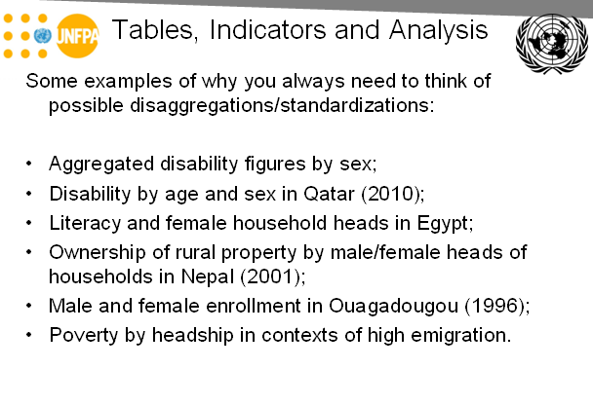
2. What indicator should be calculated to show the differential impact of disabilities on the school attendance of boys and girls? (Graph also available on slide 24 – Session 8 UNFPA presentation)
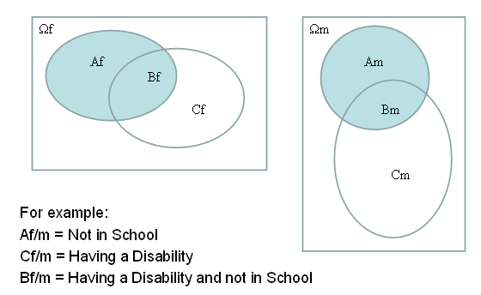
3. Identify the issue in correlating (in the following graph) total fertility rate as a function of the female/male ratio of the population with at least secondary education (country-level data covering all regions of the world).
