SDG indicator metadata
(Harmonized metadata template - format version 1.1)

0. Indicator information (SDG_INDICATOR_INFO)

0.a. Goal (SDG_GOAL)

Goal 6: Ensure availability and sustainable management of water and sanitation for all

0.b. Target (SDG_TARGET)

Target 6.3: By 2030, improve water quality by reducing pollution, eliminating dumping and minimizing release of hazardous chemicals and materials, halving the proportion of untreated wastewater and substantially increasing recycling and safe reuse globally

0.c. Indicator (SDG_INDICATOR)

Indicator 6.3.1: Proportion of domestic and industrial wastewater flows safely treated

0.d. Series (SDG_SERIES_DESCR)

EN_WWT_GEN - Total wastewater generated (million m3/year) [6.3.1]

EN_WWT_TREAT - Total wastewater treated (million m3/year) [6.3.1]

EN_WWT_TREATR - Proportion of wastewater treated [6.3.1]

0.e. Metadata update (META_LAST_UPDATE)

2023-12-15

0.f. Related indicators (SDG_RELATED_INDICATORS)

The domestic portion of wastewater treated is closely linked to indicator 6.2.1a on the “proportion of population using safely managed sanitation services”, and draws upon some of the same data sources.

The indicator is also directly linked to indicator 6.3.2 on the “proportion of bodies of water with good ambient water quality”, because unsafe wastewater treatment leads to degradation in quality of the receiving waters. It directly informs progress towards target 6.3 and is strongly linked to target 6.6 on water-related ecosystems, as well as target 14.1 on marine pollution (coastal eutrophication).

0.g. International organisations(s) responsible for global monitoring (SDG_CUSTODIAN_AGENCIES)

United Nations Human Settlements Programme (UN-Habitat)

World Health Organization (WHO)

United Nations Statistics Division (UNSD)

1. Data reporter (CONTACT)

1.a. Organisation (CONTACT_ORGANISATION)
United Nations Human Settlements Programme (UN-Habitat)
World Health Organization (WHO)
United Nations Statistics Division (UNSD)

2. Definition, concepts, and classifications (IND_DEF_CON_CLASS)

2.a. Definition and concepts (STAT_CONC_DEF)
Definitions:
This indicator measures the volumes of wastewater which are generated through different activities, and the volumes of wastewater which are safely treated before discharge into the environment. Both of these indicators are measured in units of 1000 m³/day, although some data sources may use other units that require conversion. The ratio of the volume treated to the volume generated is taken as the ‘proportion of wastewater flow safely treated’.

Wastewater flows will be classified into industrial, services, and domestic flows, with reference to the International Standard Industrial Classification of All Economic Activities Revision 4 (ISIC). To the extent possible, the proportion of each of these waste streams that is safely treated before discharge to the environment will be calculated.

Concepts:
Total wastewater generation and treatment can be quantified at the national level, and wastewater can also be disaggregated into different types of flows, based on ISIC categories. Domestic wastewater generated by private households, as well as wastewater generated by economic activities covered by ISIC categories, may or may not be pre-treated on premises before discharge to either the sewer for further treatment or directly to the environment, as shown in Figure 1.
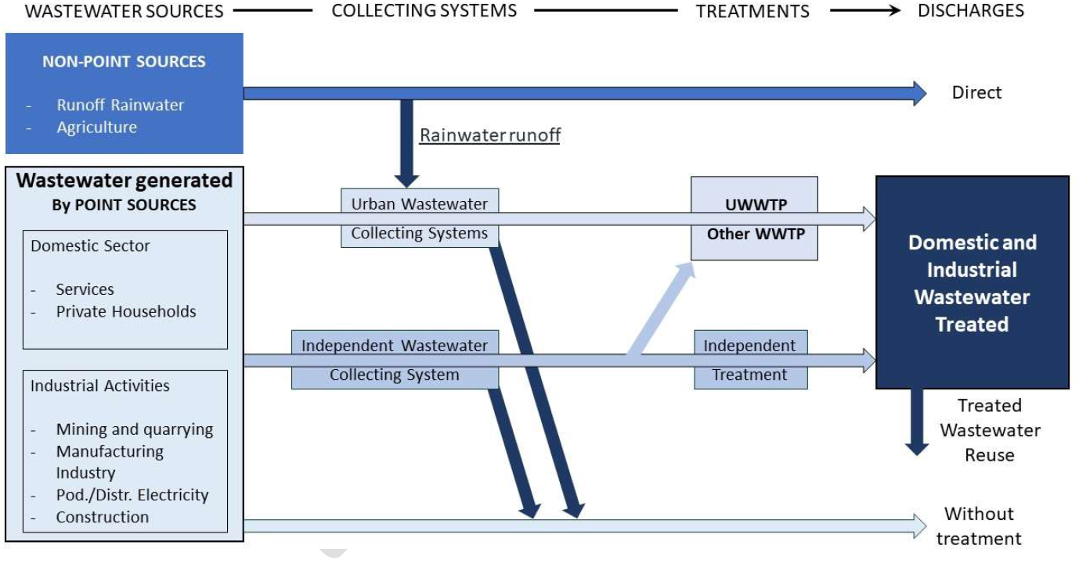
Figure 1: Schematic Representation of wastewater sources, collecting systems and treatment
(modified from wastewater loading diagram, OECD/Eurostat 2018).

The main sources of wastewater include wastewater from households, services and industries, i.e. point sources of one or more pollutant(s) that can be geographically located and represented as a point on a map. Diffused pollution from non-point sources such as runoff from urban and agricultural land can contribute quite significantly to wastewater flows (Figure 1), and therefore its progressive inclusion in the global monitoring framework will be important. Presently, it cannot be monitored at source and its impact on ambient water quality will be monitored under indicator 6.3.2 “Proportion of bodies of water with good ambient water quality”.

Differentiating between the different wastewater streams is important as policy decisions need to be guided by the polluter pays principle. However, wastewater conveyed by combined sewers usually combines both hazardous and non-hazardous substances discharged from different sources, but also runoff and urban stormwater, which cannot be separately tracked and monitored. As a consequence, although the flow of wastewater generated can be disaggregated by sources (domestic, services industrial), the treated wastewater statistics are most commonly disaggregated by type (e.g. urban and industrial) and/or level of treatment (e.g. secondary) rather than by sources.

Total wastewater flows can be classified into three main categories (see ‘disaggregation section’ for details:
- Industrial (ISIC divisions 05-35)
- Services (ISIC divisions 45-96)
- Domestic (private households)

Wastewater treatment can be classified into three main categories (see ‘disaggregation section’ for details:
- Primary
- Secondary
- Tertiary

Where possible, treatment will additionally be classified into either on-premises or off-premises treatment.

Domestic wastewater: Wastewater from residential settlements which originates predominantly from the human metabolism and from household activities.
Industrial (process) wastewater: Water discharged after being used in, or produced by, industrial production processes and which is of no further immediate value to these processes. Where process water recycling systems have been installed, process wastewater is the final discharge from these circuits. To meet quality standards for eventual discharge into public sewers, this process waste-water is understood to be subjected to ex-process in-plant treatment. Cooling water is not considered here. Sanitary wastewater and surface runoff from industries are also excluded here.
Total wastewater generated is the total volume of wastewater generated by economic activities (agriculture, forestry and fishing; mining and quarrying; manufacturing; electricity, gas, steam and air conditioning supply; and other economic activities) and households. Cooling water is excluded.
Urban wastewater: Domestic wastewater or the mixture of domestic wastewater with industrial wastewater and/or runoff rain water.
Wastewater: Wastewater is water which is of no further value to the purpose for which it was used because of its quality, quantity or time of occurrence. Cooling water is not considered here.
Wastewater discharge: The amount of water (in m3) or substance (in kg BOD/d or comparable) added/leached to a water body (Fresh or non-fresh) from a point source.
Wastewater treatment: Process to render wastewater fit to meet applicable environmental standards or other quality norms for recycling or reuse.

2.b. Unit of measure (UNIT_MEASURE)

2.c. Classifications (CLASS_SYSTEM)

3. Data source type and data collection method (SRC_TYPE_COLL_METHOD)

3.a. Data sources (SOURCE_TYPE)
A clear specification of the terminology and methodology for wastewater statistics is essential to contribute to harmonising international data collection practices and SDG 6.3.1 reporting. The objective of indicator 6.3.1 is to cover households and the entire economy, and to build on the existing international methodology for global monitoring wastewater generation and treatment. This approach reduces the monitoring burden that SDG reporting can impose on countries, and provides well-defined and internationally comparable variables for global data analysis and use by policymakers and urban/land planners.

Data are extracted from a number of pre-existing sources:

- Indicator tables from the UNSD/UNEP data collection on environment statistics
https://unstats.un.org/unsd/envstats/qindicators (refer to “Inland Water Resources”)
- Country files from the UNSD/UNEP data collection on environment statistics (https://unstats.un.org/unsd/envstats/country_files)
- Website of Eurostat water statistics (https://ec.europa.eu/eurostat/web/environment/water)
- Website of OECD water statistics (https://stats.oecd.org/index.aspx?DataSetCode=water_treat#).
- Country files from the WHO/UNICEF Joint Monitoring Programme for Water Supply, Sanitation and Hygiene (JMP) data collection on safely managed sanitation services, and the reports referenced therein
(https://washdata.org/)

3.b. Data collection method (COLL_METHOD)
Total flows of wastewater generated and treated are reported by countries to UNSD and OECD/Eurostat databases. Eurostat deals with Member States of the European Union (EU) and the European Free Trade Association (EFTA) as well as the respective candidate countries. OECD works with all its Member States not contacted by Eurostat. UNSD sends the UNSD/UNEP Questionnaire to the rest of the world (approx. 165 countries). However, the response rate for the UNSD/UNEP questionnaire is around 50% and data completeness and quality remain a challenge, especially for developing countries. While efforts will continue to collect data from National Statistical Offices and Ministries of Environment at the national level, it is also critical to improve the availability and accessibility of wastewater statistics and increase training for collection of data and capacity development at the national and sub-national levels.

The WHO/UNICEF Joint Monitoring Programme for Water Supply, Sanitation and Hygiene (JMP) collects and compiles national data related to use of sanitation services including wastewater treatment, for calculation of SDG indicator 6.2.1a “proportion of the population using safely managed sanitation services.” National data sources are collected from National Statistical Offices, ministries responsible for service delivery, and regulatory authorities, as well as other regional and global initiatives (e.g. the European Protocol on Water and Health). The database is updated every two years following a country consultation process facilitated by WHO and UNICEF regional offices.

These databases rely on a comparable harmonized terminology for water statistics. Wastewater data are nonetheless still relatively sparse on a global scale. UN-Habitat and WHO will disseminate information about these data collection processes, and will liaise with their technical focal points in regions and countries, to work with them to produce estimates which could then feed into the official statistical system via the NSOs. It is expected that over time, a better reporting of the wastewater data collected can be made to populate the SDG Indicator 6.3.1.

3.c. Data collection calendar (FREQ_COLL)
Next UNSD/UNEP and OECD/Eurostat data collection to be conducted in second half of 2020.

3.d. Data release calendar (REL_CAL_POLICY)
The global databases for indicator 6.3.1 is planned to be updated in the second quarter of 2021.

3.e. Data providers (DATA_SOURCE)
National Statistical Offices (NSOs) are the primary responsible authorities for providing data to be used for global statistics. NSOs may draw on data collected or compiled by relevant national or other authorities, such as ministries, municipalities, or regulatory authorities.

3.f. Data compilers (COMPILING_ORG)
United Nations Human Settlements Programme (UN-Habitat), World Health Organization (WHO), and the United Nations Statistics Division (UNSD) are co-custodians for this indicator at the global level.

UNSD leads on collecting, compiling, and processing of data submitted by National Statistical Offices through the UNSD/UNEP Questionnaire on Environment Statistics for the non-OECD/Eurostat member states.

UN-Habitat leads on collecting, compilation, and processing of data from UNSD and OECD/Eurostat databases. UN-Habitat also leads on collection of additional data on industrial wastewater generation and treatment.

World Health Organization (WHO) leads on collection, compilation and processing of additional data on domestic wastewater generation and treatment.

3.g. Institutional mandate (INST_MANDATE)

4. Other methodological considerations (OTHER_METHOD)

4.a. Rationale (RATIONALE)
Wastewater data are crucial to promote strategies for sustainable and safe wastewater use or reuse to the benefit of the world’s population health and the global environment, but also to respond to growing water demands, increasing water pollution loads, and climate change impacts on water resources.

Sustainable Development Goal 6 (SDG 6) is about ensuring the availability and sustainability of water and sanitation for all by 2030. SDG Target 6.3 sets out to improve ambient water quality, which is essential to protecting both ecosystem and human health, by eliminating, minimizing and significantly reducing different streams of pollution into water bodies.

The purpose of monitoring progress using SDG indicator 6.3.1 is to provide necessary and timely information to decision makers and stakeholders to make informed decisions to accelerate progress towards reducing water pollution, minimizing release of hazardous chemicals and increasing wastewater treatment and reuse. The target wording covers wastewater recycling and safe reuse with implication on water use efficiency, although it is not fully addressed by the global indicator and methodology.

SDG indicator 6.3.1 tracks the proportion of wastewater flows from households, services and industrial economic activities that are safely treated at the source or through centralized wastewater treatment plants before being discharged into the environment, out of the total volume of wastewater generated.

4.b. Comment and limitations (REC_USE_LIM)
There is a relative lack of knowledge about the volumes of wastewater generated and treated, because wastewater statistics are in an early stage of development in many countries and not regularly produced or reported. Monitoring is relatively complex, costly, and data are not systematically aggregated to the national level and/or accessible; especially industrial wastewater data which are in general poorly monitored and seldom aggregated at national level.

To some extent, this may be explained by the fact that a large proportion of the industrial water requirements are covered by the use of private systems using non-public/drinking water supply (groundwater, rivers and wells) which are not systematically included in the national statistics.

Diffused pollution from non-point sources such as runoff from urban and agricultural land can contribute significantly to wastewater flows, and therefore its progressive inclusion in the global monitoring framework will be important. Presently, it cannot be monitored at source and its impact on ambient water quality will be monitored indirectly under indicator 6.3.2 on the proportion of bodies of water with good ambient water quality.

Different types of wastewater have different degrees of contamination and pose different levels of threat to the environment and public health. Some data exist on the pollutant loading in terms of BOD5 and COD (kg O2/day), but these are not as widely available as data on volumes and will not be used at present for indicator 6.3.1. It is anticipated that future data drives will include more information on pollutant loadings that could be eventually featured in SDG 6.3.1 reporting.

Finally, whether wastewater is classified as safely treated or not depends on the wastewater treatment plant’s compliance rate to the effluent standards (i.e. performance). Many wastewater plants produce effluent which does not meet quality standards, due to improper design or loading. Effluent standards rely on both national and local requirements, as well as on specific water uses and potential reuse options, so that this approach may not provide strictly comparable variables between countries. For the purposes of global monitoring, in the absence of data on compliance, technology-based proxies will be used, in which compliance is assumed if the treatment plant provides at least secondary treatment.

4.c. Method of computation (DATA_COMP)
The amount of wastewater generated is calculated by summing all of the wastewater generated by different economic activities and households. Wastewater flows are expressed in units of 1000 m3/day, although some data sources may use other units that require conversion.

The amount of wastewater safely treated is calculated by summing all of the wastewater flows which receive treatment considered equivalent to secondary treatment or better. This wastewater flow is expressed in units of 1000 m3/day, although some data sources may use other units that require conversion.

The proportion of wastewater flows which are safely treated is calculated as a ratio of the amount of wastewater safely treated to the amount of wastewater generated.

4.d. Validation (DATA_VALIDATION)

4.e. Adjustments (ADJUSTMENT)

4.f. Treatment of missing values (i) at country level and (ii) at regional level (IMPUTATION)
• At country level
Outside of the UNSD and OECD/Eurostat databases, data on wastewater generation and treatment are not widely available, and what data do exist may not align with international definitions and classifications (e.g. ISIC codes).

For statistics on total wastewater generated and treated, missing values are not imputed. No estimated or modelled data are produced.

Some countries do not separately report the volume of wastewater generated by households. In the absence of reported data on domestic wastewater generation, an estimate of the wastewater generated at the household level will be made. It can be estimated that 80% of the water supply which enters private households will subsequently exit the household as wastewater. Therefore, if data are available on per capita water consumption, these can be used to estimate domestic wastewater generation. If data on per capita water consumption are not available, data from household surveys and censuses can be used to indicate the proportion of the population which has water supplies available on premises (e.g. municipal piped water, private boreholes with overhead tanks) and the proportion of the population which collects water from off-premises sources (e.g. communal standposts, community boreholes). In the absence of other data on domestic water consumption, it can be estimated that households with on-premises water supply consume approximately 120 litres per capita per day, and therefore generate 96 litres of wastewater per capita per day; those with off-premises water supply are assumed to consume approximately 20 litres per capita per day, and therefore generate 16 litres of wastewater per capita per day.

Missing values needed for calculation of the proportion of domestic wastewater which receives appropriate treatment will be handled in a similar way to the calculation of ‘safely managed sanitation services’ for SDG indicator 6.2.1. Domestic wastewater which enters sewage lines will be assumed to reach centralized wastewater treatment plants, unless national data is available about leakage from sewage lines. The volume of domestic wastewater estimated to reach treatment plants will be compared against the volume of wastewater reported to be received at wastewater plants, and the volume reportedly received will be taken as an upper limit to the amount of domestic wastewater which receives off-site treatment. If data are available on the proportion of wastewater flows received by centralized treatment plants which receive secondary treatment or better, this proportion can be assumed to apply equally to the flows generated by households, industries, and services which discharge into public sewers. Domestic wastewater which enters on-site storage and treatment systems such as septic tanks will be assumed to be safely treated if national data on compliance of on-site wastewater treatment systems to relevant standards are available. In the absence of such data, half of the wastewater discharged into on-site storage and treatment systems will be considered to receive safe treatment.

Given the data limitations, especially on non-household wastewater, data currently available on compliance with discharge permits could be used to better to estimate the industrial flows treated.

• At regional and global levels
See ‘regional aggregates’.

4.g. Regional aggregations (REG_AGG)
Regional and global aggregates are produced by combining volumes of wastewater generated and treated from countries with data. For the purpose of calculating regional aggregate statistics, values for countries without national estimates are imputed on the basis of regional averages (e.g. using M49 sub-regions). These imputed data are never published separately as national statistics.

Regional and global aggregate statistics are only produced when the data available without imputation represent at least 50% of the regional or global total. Ideally this coverage threshold would be based on wastewater volumes, but data on the volumes of wastewater generated are not available for all countries. Accordingly, as an interim measure, data coverage thresholds and weighting of national statistics will be done on the basis of national population, drawing on the latest statistics available from the UN World Population Prospects.

4.h. Methods and guidance available to countries for the compilation of the data at the national level (DOC_METHOD)
To be developed.

4.i. Quality management (QUALITY_MGMNT)

4.j Quality assurance (QUALITY_ASSURE)
Data submitted to UNSD or OECD/Eurostat come directly from national statistical offices and/or ministries of environment. Data treatment and validation is done jointly by Eurostat and the OECD for their member states according to an agreed process and timeline. For those data submitted to UNSD a review is undertaken by the Environment Statistics Section for consistency. UNSD carries out extensive data validation procedures that include built-in automated procedures, manual checks and cross-references to national sources of data. Communication is carried out with countries for clarification and validation of data. UNSD does not make any estimation or imputation for missing values so the number of data points provided are actual country data. Only data that are considered accurate or those confirmed by countries during the validation process are included in UNSD’s environment statistics database and disseminated on UNSD’s website.
UN-Habitat and WHO use the resulting data without modification. In case of any observed discrepancies or anomalies the national authorities are consulted for clarification.

Estimates of domestic wastewater treatment are calculated based on national data and will be shared with countries for a consultation process similar to, and coordinated with, the consultation process used by WHO and UNICEF for indicators 6.1.1 and 6.2.1.

4.k Quality assessment (QUALITY_ASSMNT)

5. Data availability and disaggregation (COVERAGE)
Data availability:
In 2018 estimates of data on ‘proportion of safely treated domestic wastewater flows’ were available for 79 countries. These are available through the UN SDG Database (EN_WWT_WWDS). No regional aggregates were produced due to low data coverage.

The UNSD/UNEP Questionnaire on Environment Statistics has collected data on wastewater generation and treatment for about 7 years. The Questionnaire has been sent to more than 160 countries, covering both national and city levels. However, the response rate for the UNSD/UNEP questionnaire is hovering around 50% and data completeness and quality remain a challenge, especially for developing countries.

For those variables relevant to this indicator which are collected via the UNSD/UNEP Questionnaire, data for up to 37 countries are available in some years (wastewater treated in urban wastewater treatment plants), though for other relevant variables, for a given year, data for 30 countries or less may be available. More details on the availability of data obtained from the UNSD/UNEP Questionnaire can be found in the Report of the Secretary-General on Environment Statistics (Part C) and the Background Report (Part 1) submitted to the fifty-first session of the Statistical Commission (New York, 3-6 March 2020). Data received via the UNSD/UNEP Questionnaire have been published on the UNSD website in the form of indicator tables (UNSD Indicator Tables (inland water resources) (https://unstats.un.org/unsd/envstats/qindicators) as well as in Country Files (https://unstats.un.org/unsd/envstats/country_files).

Time series:
Some indicators have time series available for multiple years, while others currently only have most recent year availability.

Disaggregation:
Wastewater generation (Figure 2)
Wastewater can be generated through a variety of economic activities as well as through private households. The following categories of wastewater flows can be distinguished:
- Agricultural (ISIC 01-03) covers crop and animal production, hunting and related service activities; forestry and logging; and fishing and aquaculture. Wastewater generated from these activities for the most part enters the environment as non-point pollution and will not be monitored as part of indicator 6.3.1.
- Mining and quarrying (ISIC 05-09) includes the extraction of minerals occurring naturally as solids (coal and ores), liquids (petroleum) or gases (natural gas). Extraction can be achieved by different methods such as underground or surface mining, well operation, seabed mining etc.
- Manufacturing (ISIC 10-33) includes the physical or chemical transformation of materials, substances, or components into new products. The materials, substances, or components transformed are raw materials that are products of agriculture, forestry, fishing, mining or quarrying as well as products of other manufacturing activities. Substantial alteration, renovation or reconstruction of goods is generally considered to be manufacturing.
- Electricity (ISIC 35) includes electric power generation, transmission and distribution, as well as the manufacture and distribution of gas, and steam and air conditioning supply. Water used for cooling in power generation is explicitly excluded from calculations of wastewater flows.
- Construction (ISIC 41-43) includes general construction and specialized construction activities for buildings and civil engineering works. It includes new work, repair, additions and alterations, the erection of prefabricated buildings or structures on the site and also construction of a temporary nature.
- Services (ISIC 45-96) These Divisions are considered service industries and include a wide range of economic activities where water is mainly used for sanitary purposes, washing, cleaning, cooking, etc.
- Wastewater can also be generated by private households, originating predominantly from the human metabolism and from household activities. A portion of the water which is brought into private households for domestic purposes (e.g. cooking, drinking, bathing, washing, ISIC division 36) exits the household as wastewater. Domestic wastewater flows are not directly covered by ISIC codes, unless the household generates water in the course of an economic activity. Note that wastewater generated by residents of communal institutions may be covered under ISIC divisions, e.g. 85 (education) or 87 (residential care activities).

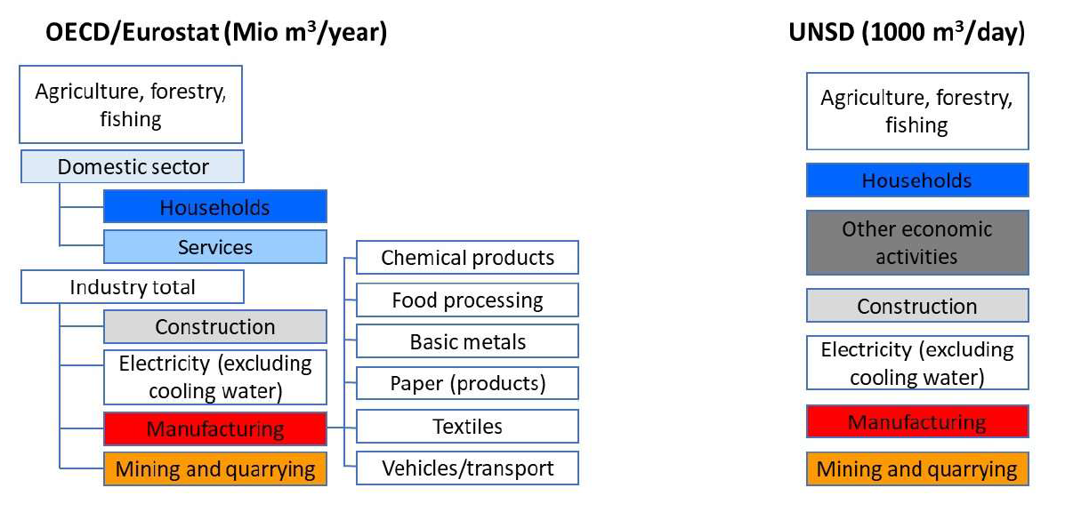
Figure 2. OECD/Eurostat (left) and UNSD/UNEP (right) variables for the generation of wastewater flow. The variables used to populate the SDG Indicator 6.3.1 are highlighted in colour.

Wastewater treatment (Figure 3)
OECD/Eurostat databases disaggregate the flow of treated wastewater by type (e.g. urban and industrial discharges), whereas the UNSD database reports the flow of wastewater treated in other treatment plants and in urban wastewater treatment plants (see definitions below) by level of treatment (primary, secondary and tertiary). The variables and terms used for indicator 6.3.1 are listed below.

Urban wastewater treatment is all treatment of wastewater in Urban Wastewater Treatment Plants (UWWTP’s). UWWTP’s are usually operated by public authorities or by private companies working by order of public authorities. It includes wastewater delivered to treatment plants by trucks. UWWTP's are classified under ISIC 37 (Sewerage).

Independent treatment: Facilities for preliminary treatment, treatment, infiltration or discharge of domestic wastewater from dwellings generally between 1 and 50 population equivalents, not connected to an urban wastewater collecting system. Examples of such systems are septic tanks. Excluded are systems with storage tanks from which the wastewater is transported periodically by trucks to an urban wastewater treatment plant.

Other wastewater treatment corresponds to treatment of wastewater in any non-public treatment
plant, i.e., Industrial Wastewater Treatment Plants (IWWTPs). Excluded from "other wastewater treatment" is the treatment in septic tanks. IWWTPs may also be classified under ISIC 37 (Sewerage) or under the main activity class of the industrial establishment they belong to.

Non-treated wastewater is wastewater which doesn’t undergo any form of treatment before discharge to the environment.

Primary wastewater treatment: Treatment of wastewater by a physical and/or chemical process involving settlement of suspended solids, or other process in which the Biochemical Oxygen Demand (BOD₅) of the incoming wastewater is reduced by at least 20% before discharge and the total suspended solids of the incoming wastewater are reduced by at least 50%. To avoid double counting, water subjected to more than one type of treatment should be reported under the highest level of treatment only.

Secondary wastewater treatment: Post-primary treatment of wastewater by a process generally involving biological treatment with a secondary settlement or other process, resulting in a Biochemical oxygen demand (BOD) removal of at least 70% and a Chemical Oxygen Demand (COD) removal of at least 75%. Natural biological treatment processes are also considered under secondary treatment if the constituents of the effluents from this type of treatment are similar to the conventional secondary treatment. To avoid double counting, water subjected to more than one type of treatment should be reported under the highest level of treatment only.

Tertiary wastewater treatment: Treatment (additional to secondary treatment) of nitrogen and/or phosphorous and/or any other pollutant affecting the quality or a specific use of water: microbiological pollution, colour etc. The different possible treatment efficiencies ('organic pollution removal' of at least 95% for BOD₅, 85% for COD, 'nitrogen removal' of at least 70%, 'phosphorous removal' of at least 80% and 'microbiological removal') cannot be added and are exclusive. To avoid double counting, water subjected to more than one type of treatment should be reported under the highest level of treatment only.

For all of these treatment categories, some but not all countries have data available on the compliance of treatment to relevant effluent standards or targets. When available, such data are not routinely reported to UNSD or OECD/Eurostat, but may be available in other national data sources (e.g. statistical or wastewater analysis reports). Where available, data on the proportion of flows that meet relevant criteria will be used for indicator 6.3.1. In the absence of such data, treatment nominally classified as secondary or better (or equivalent) will be used as a proxy for safe treatment.
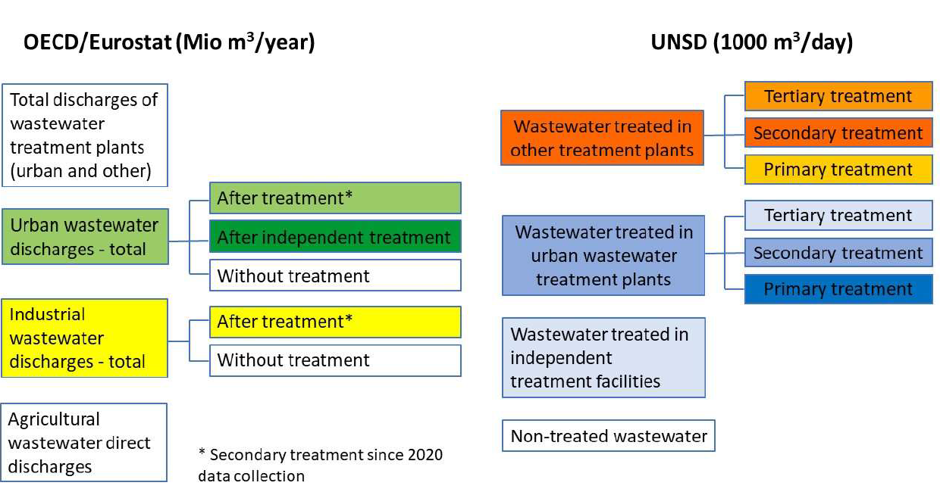
Figure 3. OECD/Eurostat (left) and UNSD/UNEP (right) variables for the treatment of wastewater flow. The variables to populate the SDG Indicator 6.3.1 are highlighted in colour.

Where it is possible to quantify both generation and treatment by source (industrial, service, or domestic), the proportion of wastewater treated will also be calculated separately by source.

6. Comparability / deviation from international standards (COMPARABILITY)
Sources of discrepancies:
To be developed.

7. References and Documentation (OTHER_DOC)
URL:

References:
- OECD/Eurostat, 2018. Data Collection Manual for the OECD/Eurostat Joint Questionnaire on Inland Waters and Eurostat regional water questionnaire.
- UNSD, 2018. International Standard Industrial Classification of All Economic Activities, Revision 4. https://unstats.un.org/unsd/publication/seriesm/seriesm_4rev4e.pdf
- UNSD/UNEP Questionnaire 2018 on Environment Statistics. https://unstats.un.org/unsd/envstats/questionnaire
- WHO and UN Habitat, 2018. Progress on Safe Treatment and Use of Wastewater 2018: Piloting the monitoring methodology and initial findings for SDG indicator 6.3.1.
https://www.unwater.org/publications/progress-on-wastewater-treatment-631/
- Manual on the Basic Set of Environment Statistics https://unstats.un.org/unsd/envstats/fdes/manual_bses.cshtml (wastewater statistics - forthcoming)
- UNSD Indicator Tables (inland water resources) (https://unstats.un.org/unsd/envstats/qindicators)

https://unstats.un.org/unsd/statcom/51st-session/documents/2020-33-EnvironmentStats-E.pdf
https://unstats.un.org/unsd/statcom/51st-session/documents/BG-item-4e-EnvironmentStats-E.pdf

