Energy Statistics- United Arab
Emirates Experience
8th Oslo group meeting
Baku – Azerbaijan
24- 27 sep.2013

Prepared by
Khamis Raddad
United Arab Emirates
National Bureau of Statistics

Introduction
Energy production is an essential part of the economy in the UAE. Thus, reliable and exhaustive energy statistics is necessary for a current evaluation of the development and for strategic planning of future activities for both government and private sectors. Both physical, values and prices data of energy sources are needed, so It is important to provide up to date; high quality and comprehensive energy statistical data for both national and international users.
It should also be noted that good energy data may form an important input to the national accounts. Without reliable data on supply and use of energy an important part of the economy cannot be described adequately well.
a- Country profile
United Arab Emirates (UAE) is a federal state made up of independent and sovereign federation of seven emirates, are: Abu Dhabi, Dubai, Sharjah, Ajman, Umm Al-Qiwain, Ras Al- Khaimah and Fujairah.
The country area is around 71,023.6 square kilometres. This area includes the islands in the Arabian Gulf and the Territorial sea area is 27,624.9 square kilometres.
The United Arab Emirate (UAE) is Located in the North-Eastern area of the Arabian Peninsula, approximately between 51° 35`- 57° 10` longitudes, and 22° 35`- 26° 25` latitudes ,

b- UAE statistical office
The Head Office of National Bureau of Statistics is located in Abu Dhabi, while regional NBS offices are located in five emirates: Ajman, Fujairah, Ras al-Khaimah, Sharjah, and Umm al-Quwain.

NBS Organizational Structure
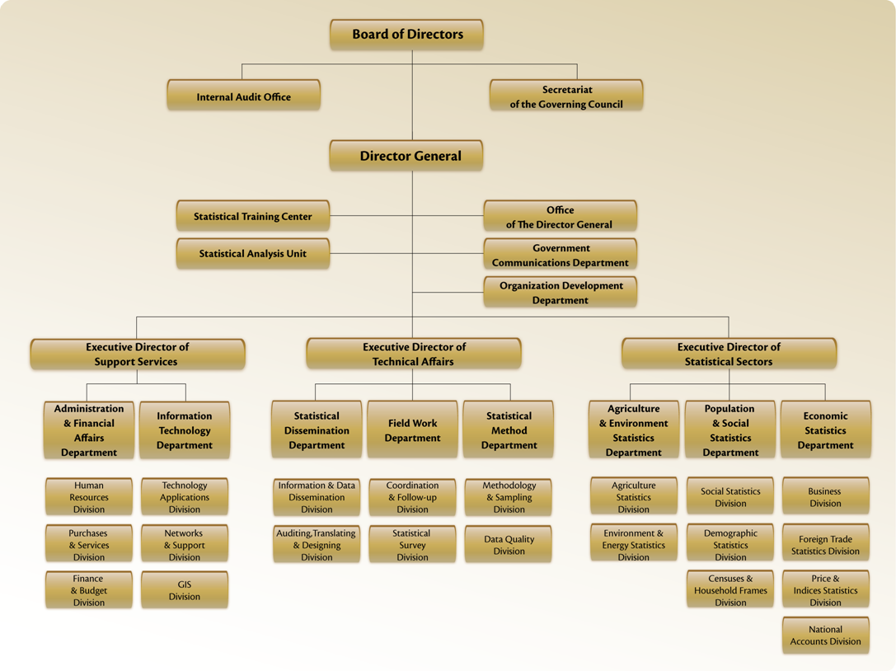
The emirates of Abu Dhabi and Dubai have their own independent statistical centres: The statistical Centre of Abu Dhabi (SCAD) and Dubai Statistics Centre (DSC).
They carry out all collection of data for Abu Dhabi and Dubai, while the NBS takes care of the data collection, etc. for the five other emirates. The SCAD and the DSC are committed to coordinate their activities with the NBS.
Data are transferred from the Statistical Centres of Abu Dhabi and Dubai to the NBS in order to make it possible for the NBS to produce national statistics including all seven emirates.
Main activities in energy and energy statistics
- The UAE has shown great interest in the different sources of Energy and developing them and promoted research in this field. The UAE started producing Energy more than half a century ago, in this economic context, and to enhance its cognitive efforts, the UAE has carried out many pioneering activities in the field of developing Energy.
- In order to enhance the economic Sustainable Development, the UAE hosted the International Renewable Energy Agency (IRENA).
- In the matter of statistical work and Energy Statistics, NBS was keen on Including this topic within the scope of its interest since its establishment, where an organizational unit concerned with Energy Statistics has been established, and this comes to reflect the fourth Item of Article 4 of NBS's law of establishment, which states that among the functions of NBS is the collection of statistical data in the field of energy.
- Since its establishment, NBS has carried out many activities related to building databases concerning Energy Statistics as follow:
- developing an action plan for this type of statistics,
- hosting Experts from the ESCWA to evaluate the reality of energy statistics in the UAE,
- It also created Energy Statistics output tables and communicated with the partners to reach a clear vision about how to create accurate and effective energy statistics.
- NBS collected energy data and produced many tables on the production and use if Energy as a time series.
- Hosted the regional workshop on energy statistics.
Energy statistics plan
The NBS put strategic plan to initiate and improve the energy statistics. This plan consists of three stages and it covers the main topics as follow:
- Framework of the energy statistics
- Institutionalize the work of energy statistics.
- Energy statistics in the National Bureau of Statistics.
- Topics to be covered by the energy statistics.
- Sources of energy data.
- Agencies dealing powered
- Assessment of the current situation
- Suggested surveys to be conducted for energy statistics
- Suggested Strategic Plan and action plan

Main objectives of energy statistics:
- Collection and tabulation of data from various sources of energy.
− Conduct field surveys on energy statistics.
− Processing and tabulating the collected questionnaire and raw data.
− Prepare of annual and quarterly reports in the field of energy.
− Provide users with energy statistical data.
− Fill in the forms of international and regional agencies.
− Create a database of energy.
− Develop a methodology and prepare manuals for energy statistics.
− Participate in seminars and meetings on energy statistics.

Dummy tables:
About 30 dummy tables were created in energy statistics under these main topics:
- Oil and gas reserves
- Oil and gas extraction
− Use of energy sources by sector and economic activity
− Exports and imports of energy sources and energy products
− Activities of oil refineries
− Energy balance
− Electricity production and consumption by source and economic activity
− Renewable energy sources
- Energy prices
- Air emission resulting from extraction activity and energy use
- Selected indicators for energy statistics

Assessment of the situation
During 2007 the NBS conduct assessment activity for environment statistics including the energy topic, then during 2012 under the regional project for strengthening capacity for the ESCWA countries in energy statistics the ESCWA conducted a mission to UAE to make assessment for the current situation on energy statistics, this mission takes place during the period 19-21 June 2012.

Suggestions for the development of energy statistics in the UAE
As a result of the assessment mission a set of suggestions to improve energy statistics were suggested as follow:
- Building metadata and ensuring the quality and exhaustiveness of already existing statistics for petroleum, gas and electricity.
- Complementing with new statistics for areas not yet covered, especially the use of the energy by industries and households.
- It is suggested to transfer the responsibility of collecting and processing the energy data from the companies to the Statistical offices. In order to enhance the ability of NBS in produce a reliable statistics for the supply side of the energy system.
- It is suggested to put effort to build metadata and further documentation of data and original sources and to make this available for users by publishing it together with the statistics.
- It is suggested to develop publication of a coherent statistics for the supply and exports of electricity, petroleum and natural gas together with the documentation of the statistics should by the responsible organization.
- In order to ensure that the reporting is useful for statistical purposes it is recommended that the existing international guidelines and reporting templates are taken into consideration in coordinating and streamlining the reporting from energy producing companies.

Coordination committee
The NBS has been established a national committee for energy statistics, which held regular meetings in ordered to achieve its goals and to make further improvements in the existing cooperation and data exchange.
  - The main tasks of the Committee are:
  - − coordination among all relevant authorities for the establishment and development of energy data base at the country level, and make use of databases produced by the local authorities.
  - − Identify sources of energy data and collect all data available in each source.
  - − Consolidation and generalization of concepts and definitions of energy and energy statistics among all stakeholders.
  - − Assess the situation of the available data at concerned parties and the necessary data for energy statistics.
  - − Coordination among all stakeholders to provide data on production, export and import, transformation, and consumption of all kinds of energy.
  - Recommend the implementation of surveys to provide data that are not available in official registers, and the data necessary to calculate the energy balance.
The committee includes the following entities
− National Bureau Statistics.
− Masdar Company.
− Abu Dhabi Center for Statistics
− Dubai Statistics Center
− The Federal Authority for Electricity and Water
− Ministry of Energy
Main challenges
The main challenge is to maintain a system of energy statistics and updated the data, which requires the development of guidelines and rules for the work of energy statistics, and develop a program to collect, compile and aggregate energy statistics on the local and national level, as part of the national statistical system. This work requires concerted efforts among various stakeholders on energy statistics.
The Improvements in the energy statistics and energy balances in the UAE requires allocating qualified manpower, so the scarcity of professional employees in this field is one of the main challenges.

Recommendations
In addition to the suggested recommendation by ESCWA Team, it is suggested to
- The energy statistics field is considered as new field in the region so it is suggested to improve the statistical tools in this field in Arabic langue including manuals, methodologies, standards, classification, definitions.
- It is recommended to designate of NBS for the responsibility of energy statistics including data collection, data processing and data dissemination.
- It is suggested to allocate qualified employees for this activity and provide training to the staff until reach sufficient capacity is in place.
- Improve the action plane of energy statistics and increase the cooperation and corporation with main partners.
- Put more effort on awareness of energy statistics.
In addition to the above recommendation it is suggested to apply the steps bellow to improve the situation:
- Build a flow chart of all major energy flows in the UAE including all flows of natural gas, crude oils, refined/processed energy products, and electricity with main actors/establishments identified.
- Build metadata and documentation for the existing energy statistics. Describe and clarify the existing data sources and data flows in order to establish the link between data published by the actors.
- Specify organizational and dissemination strategy for the existing and future statistics.
- Start building an energy balance for the UAE
- Work on streamlining reporting templates and procedures for the energy suppliers (report once - use many times).
- Consult with users and data providers, and adjust previous steps as appropriate

References
أولا : المراجع العربية
- وكالة الطاقة الدولية، 2005، دليل احصاءات الطاقة، فرنسا.
ثانيا المراجع الانجليزية
- PEDERSEN OLE, WAFA ABOUL HOSN, 2012, REPORT FROM THE UAE MISSION, UAE.

- United Nation, 2011, International recommendations for energy statistics, New York.
- Oslo Group on energy statistics, 2013, Energy Statistics Compilers
Manual, Oslo.

