Renewable vs. non-renewable energy sources, forms and technologies prepared by. A.Gritsevskyi, IAEA
Objective of this paper is to provide International Recommendations for Energy Statistics (IRES) with suggested definition of renewable and non-renewable energy grouping and relevant discussion that could be used in updated energy statistics manual. Second objective is to give a short literature overview with relevant definitions and argumentation. Suggestion on how renewable energy forms and corresponding transformation should be reflected in “basic” energy statistics and energy balances are largely outside of the scope of this paper.
Why is it important to introduce categorization based on renewable versus non-renewable energy?
Historically renewable energy was first energy humankind used. Going from use of fuelwood as a source of cooking and providing heat to using wind energy for transportation and later as a source of mechanical energy in first machinery renewables played absolutely essential role for development in preindustrial time.
It hard to say for sure when and in what source grouping renewables/non-renewables was introduced (my colleagues from IAEA library did not finished research on that topic yet), but most probably it become widely used around 1973-1975 as outcome of the work on energy security issues and sustainability.
There is clearly more than one reason to introduce such categorization
- “do we have sufficient energy resources?” and energy security. Also from scientific point of view all energy sources we know within a defined system (Earth) are finite some energy, for example energy obtained from fusion process, could be considered practically inexhaustible. Some energy sources have limited quantities and occurrence (fossil fuel, uranium) and could be depleted. Other, coming from nature, like solar radiation and mechanical energy produced by gravitational interactions in system Earth-Moon are limited in their flow/flux but virtually not depletable.
- Sustainability of using energy sources. All limited resources including energy resources should be used in a manner that does not to compromise needs of future generations. Amount of energy coming from exhaustible vs. inexhaustible resource is important indicator of sustainability (which is not perfectly defined term as well).
- Environmental impact and climate change. Use of “conventional” energy technologies based on fossil fuels had some records of seriously high impact on local and regional environment. It is largely accounted for significant growth of carbon dioxide and other “green” gases in atmosphere. Alternatively some energy technologies taking energy from natural flows like solar radiation and wind were viewed as environment “neutral” and potentially providing “clean” energy for unlimited period of time. Also, so far were have no technology without negative effect on environment some of them do have considerably lower and more controlled undesirable outcomes.
What is in UN F series manuals?:
Manual 44E does not differentiate between renewable and non-renewable energy.
In 29E on page 4 there is section E “New sources of energy” renewables are mentioned. They are listed (along with nuclear energy) as well as “classical” biomass production, but in cases of conventional biomass products manual suggest that “alternative energy sources might be more efficient”. In the same manual on page 8-9 par. 29 the way energy sources are mentioned it is suggesting that “hot rocks” (geothermal) is not part of renewable sources (they are explicitly listed separately). There are number of places discussing the way renewable energy should be reflected in energy balances. And on page 29 par.106 there is an attempt to give working definition:
106. "Renewable sources of energy" is a convenient label for the energy obtainable from biomass, solar radiation temperature differences that produce currents in deep oceans or that are found in rocks beneath the earth's surface, air pressure differences that produce winds, and natural or man-made differences in water levels.
In that definition it is clearly stated that geothermal and biomass are renewable energy. At the same time few paragraphs later it put reservations
108. All biomass is not necessarily renewable. Fuelwood may be 'mined' from forests or woodlands that are all too often irreparably damaged or completely destroyed by the practice. Alternatively fuelwood may be cropped from well-managed wood lots that have been specially planted with fast-growing trees or bushes suitable for this purpose. Geothermal energy, too, may or may not be renewable depending on how deep one goes when defining the heat source and on how accurately one knows the boundaries of the hot-rock mass; and on whether the rate of heat extract, ion from a relatively isolated rock mass exceeds or is less than the rate at which that mass may receive heat from a connected larger geothermal heat source.
In 56E classification from 29E are mostly re-iterated:
“The term "renewable" only applies to fuelwood grown and replaced at a rate at least equal to the rate at which it is cut”.
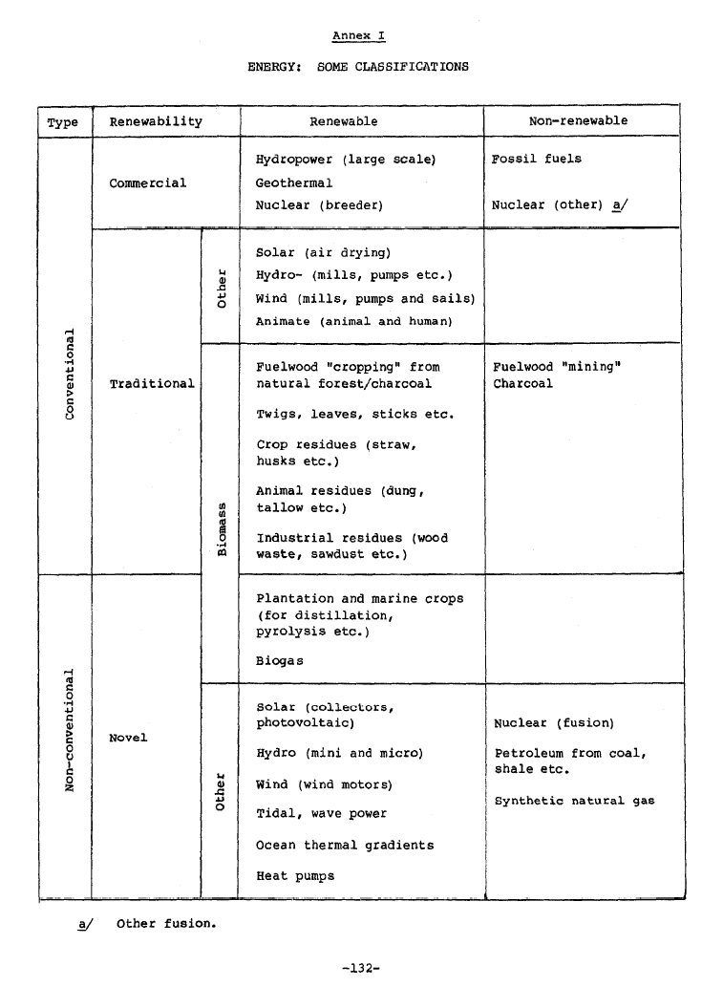

Do we have a problem(s) in distinguishing non-renewable and renewable energy? Do we have conflicting definition in the literature?
Yes we do. UN manual F-29E is in conflict with current definition used by OECD-IEA-Eurostat. F-29E is clearly indicating that fuelwood and all derived product from it that is taking from forest or woodland in non-sustainable manner is not renewable.
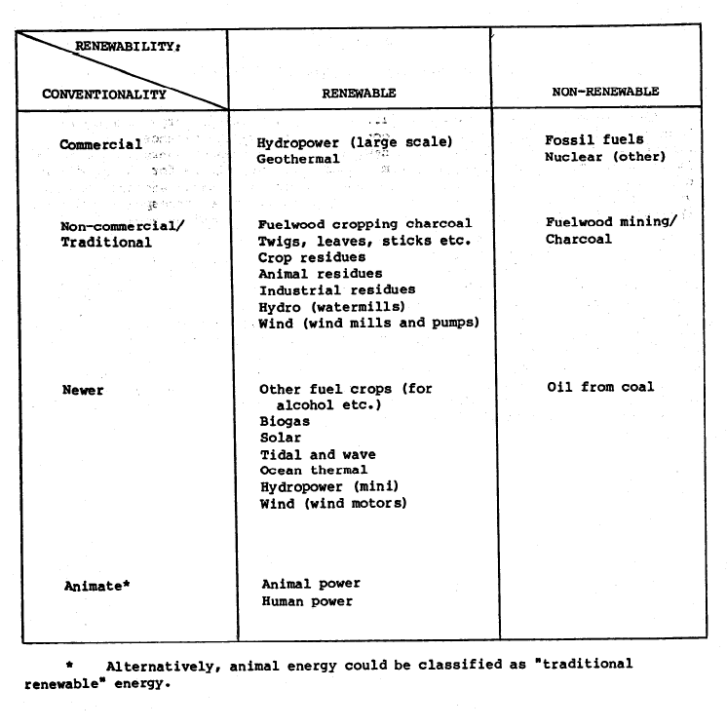
Eurostat definition: “Renewable energy sources include renewable non-fossil energy sources such as wind, solar, geothermal, hydro-power and energy from biomass/wastes. The latter refers to electricity generated from the combustion of wood and wood wastes, other solid wastes of a renewable nature (for example, straw), biogas (including landfill, sewage, and farm gas) and liquid biofuels, and from municipal solid waste incineration.”
IEA/OECD/Eurostat definition from Energy Manual (note that it rather dealing with energy form and not with energy source): “One can find numerous definitions of renewables in technical literature, including the following one: renewable energy is energy that is derived from natural processes that are replenished constantly. Although this definition leads to some issues, dealing for instance with the time horizon for the replenishment, it will be used as the reference in this chapter. There are various forms of renewable energy, deriving directly or indirectly from the sun, or from heat generated deep within the earth. They include energy generated from solar, wind, biomass, geothermal, hydropower and ocean resources, solid biomass, biogas and liquid biofuels.”
EU Commission: “Renewable energy sources are defined as renewable non-fossil energy sources: wind, solar, geothermal, wave, tidal, hydropower, biomass, landfill gas, sewage treatment plant gas and biogases.”
Few countries, including Finland and Sweden (http://www.sgu.se/sgu/eng/samhalle/energi-klimat/fornybar-energi_info_e.html), and some organizations like USGS (http://minerals.usgs.gov/minerals/pubs/commodity/peat/) label peat as “a slowly renewable biofuel” and a renewable source of energy.
WEC is suggesting to keep peat out of both groups http://www.worldenergy.org/publications/survey_of_energy_resources_2007/peat/704.asp
And gives that problematic definition: “New and Renewable Energy Sources: energy sources including solar energy, geothermal energy, wind power, hydropower, ocean energy (thermal gradient, wave power and tidal power), biomass, draught animal power, fuelwood, peat, oil shale and tar sands.”
In 1983, physicist Bernard Cohen proposed that uranium is effectively inexhaustible, and could therefore be considered a renewable source of energy. He claims that fast breeder reactors, fueled by naturally-replenished uranium extracted from seawater, could supply energy at least as long as the sun's expected remaining lifespan of five billion years and following common definition of renewable resource that is not limited only to the energy it is renewable because it is “practically inexhaustible” (see for example BusinessDictionary.com) http://sustainablenuclear.org/PADs/pad11983cohen.pdf
There are number of attempts to exclude large scale hydropower projects from the renewable category and even to question inclusion of geothermal technology in case it may lead to partial depletion of resources at some specific location.
Most of the problems originate from not completely clear definition or from possibility to (re-)interpret part of definition. Having only definition that lists renewable or just non-renewable energy leads to problems.
Principals to follow in order to provide definition
The way to provide a definition:
- Postulating (listing what it is and what it is not)
- Giving criteria and checking if particular source of energy meets it
- Combination of both
Most of existing definition using first method and some are based on second one but with criteria that allows multiple interpretations. For example:
- “New and renewable energy sources are energy sources including solar energy, geothermal energy, wind power, hydropower, ocean energy (thermal gradient, wave power and tidal power), biomass, draught animal power, fuelwood, peat, oil shale and tar sands”, UN Glossary of Environment Statistics F-67E
It is problemetic as it is not clear what is actually “new” source vs. actually renewable and what is role of “and” in that definition.
- “energy obtained from sources that are essentially inexhaustible (unlike, for example the fossil fuels, of which there is a finite supply). Renewable sources of energy include wood, waste, geothermal, wind, photovoltaic and solar thermal energy”
Problem there is related to the use of “essentially inexhaustible” that is subjective and give a possibility to argue that fusion power or peat are renewables.
- “all natural energy flows that are inexhaustible (i.e., renewable) from an anthropogenic point of view: solar radiation; hydropower; wind; geothermal; wave, and tidal energy; and biomass”, from “Renewable Energy in Europe”, Energy Encyclopedia
It is suffer from similar problem, but here at least it considers only “natural” flows.
- “Renewable Energy – Resources that are naturally replenishing but flow limited. They are virtually inexhaustible in duration but limited in the amount of energy that is available per unit of time”, from “Renewable Energy in United States”, Energy Encyclopedia
It is almost acceptable definition, but there is nothing about renewable rate.
The most suitable approach for IRES would be provide criterias and explicitly list energy sources for both categories.
Suggested approach (based on M. Hoexter post “What is Renewable Energy Anyway?”, attached)
M. Hoexter approach is based on concepts of energy flux (flow) vs. energy store (see attached document for details). In that sense all non-renewable energy is energy store. Renewable energy on the other hand, appears both as natural energy flux and as an energy store.
“Non-renewable energy sources are energy stores with zero or a minute rate of replenishment relative to its depletion by human beings. Most non-renewable energy sources are converted to usable energy by thermal or nuclear reactions. Non-renewable energy sources have stored the natural energy flux of Earth’s biological and geological past or of the formation of elements in the early history of the Universe”
“Renewable energy sources are types of natural energy flux useful for human ends regularly occurring on or near Earth’s surface and, additionally, useful natural energy stores that are replenished by natural flux within the timeframe of conceivable human use. All known renewable energy sources originate in, or are close derivatives of, electromagnetic radiation of our Sun, the Earth’s and Moon’s gravitational fields and heat radiating from earth’s interior. Renewable energy sources are practically inexhaustible though some sources such as geothermal and ocean thermal energy conversion may become locally depleted by human use at a rate that exceeds replenishment by natural flux.”

Differences between energy source, form and technology
Difficulties in categorizing, at least at some extend, emerged from mixing different energy terms: source, form and technology. There are some inconsistencies in how it is used by UN Environmental Statistics (F-67E)/OECD vs. IEA/Eurostat Manual.
F-67E: “Energy Sources: all solid, liquid and gaseous fuels; electricity; uranium; steam and hot water; and the traditional fuels such as fuelwood, charcoal, vegetal and animal wastes”.
IEA/Eurostat:”The energy source refers to the kinetic (e.g. hydro, wind), thermal (e.g. nuclear, geothermal) or combustible fuel used as the input to generate electricity or heat.” and later manual describes energy commodities and their transformations by using term “form”. It is common practice and consistent with scientific literature.
What is defined by F-67E as “energy source” is actually “energy form”. Energy that entering defined system (energy system) coming from some source (fossil, sun, wind). Energy inside of the system transformed from one form to another (jet fuel, biogas, electricity) and transformation (changing in form), transportation (moving in space), storing (shifting energy in time) is done by energy technology that takes energy form as both input and output.
Hybrid renewable technology and associated accounting
Energy technology may use multiple energy input forms and in some cases, like hybrid of natural gas-fired combined-cycle generating equipment integrated with solar thermal generating equipment, some are renewable and some are not. Output, which in that particular case electricity and heat, is not 100 % coming from renewable source and corresponding energy forms in energy balances should be reported in consistent way (effectively captured heat from solar part in energy units as well as gas input). This is in aggrement of Recommendation #16 of Oslo group.

Suggestions (explicit) to address “gray areas”
- peat – non-renewable energy form due to low and slow renewable rate, consequently technologies that using peat are non-renewable and it require check with ISEC for peat extraction activities. Origin of peat is biomass and it came from renewable energy source
- geothermal – renewable. Some use may harm amount of the energy effectively available at specific location
- fuelwood and all derived products – renewable(?) but should be discussed separately with environment statistics experts
- hydropower, both large and small scale – renewable. The same comment as for geothermal is applicable
- fission and fusions materials based – non-renewable, as potential effectively replenishing cycle could be only viewed as human made in contrast to some source geothermal energy
This should bring UN manuals in consistence with IEA/Eurostat adopted categorization.

