Summary of key facts from the inventory of training courses provided by GIST Founding Members

Training Courses by Statistical Domains

Statistical Domains | Number | Percentage
Demographic and social statistics | 35 | 8%
Economic statistics | 126 | 29%
Environment and multi-domain statistics | 25 | 6%
Leadership/strategic issues/management | 31 | 7%
Methodology of data collection, processing, dissemination and analysis | 107 | 25%
Other | 28 | 7%
SDG monitoring and SDG indicators | 27 | 6%
Statistical literacy | 9 | 2%
Strategic and managerial issues of official statistics | 41 | 10%
Total | 429 | 100%

Geographic Scope

Geographical Scope | Number | Percentage
Global | 42 | 10%
Africa | 71 | 17%
Latin America and Caribbean | 51 | 12%
Asia | 124 | 29%
Europe | 67 | 16%
Oceania | 16 | 4%
Other | 58 | 14%
Total | 429 | 100%

Training Courses by Target Audience

Target Audience | Number | Percentage
National Statistical Office (NSO) | 146 | 34%
Other government agencies in the national statistical system (OGA) | 27 | 6%
NSO and OGA | 211 | 49%
Policy makers/Politicians | 3 | 1%
Other | 42 | 10%
 | 429 | 100%

Modality of Training Courses

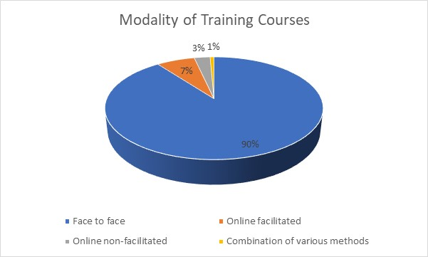

Languages of trainings

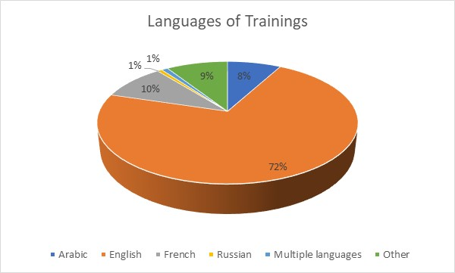

Fee for Training Courses

Certification for Training Courses

