  DEPARTMENT OF ECONOMIC AND SOCIAL AFFAIRS  STATISTICS DIVISION  UNITED NATIONS | NATIONAL BUREAU OF STATISTICS OF CHINA
____________________________________________________________________________________

International Workshop on Social Statistics

Information note for participants

United Nations Statistics Division (UNSD)
National Bureau of Statistics of China (NBS)

22-24 November 2010
Beijing, China

- Introduction

The International Workshop on Social Statistics is jointly organized by the United Nations Statistics Division/Department of Economic and Social Affairs (UNSD/DESA) and the National Bureau of Statistics of China (NBS). It will be held from 22 to 24 November 2010 in Beijing, China.

- Working language

The working language of the Workshop is English, however simultaneous Chinese interpretation will be provided.

- Time and venue

The Workshop will be held at the Tiantan Hotel.

Address: No. 1 TiYu Guan Road. DongCheng District. Beijing. China.
Tel: （86）-010-67190389
Fax: （86）-010-67190333
Website: http://www.tiantanhotel.com/

The Workshop sessions will take place at the Tiantan Hall at the 4th floor of the Tiantan Hotel. Morning sessions will start at 09:00 AM, while afternoon sessions – at 14:00 PM. The lunch break will be between 12:00-14:00 PM.

- Registration

Registration of participants starts at 8:00 AM, Sunday, 21 November 2010 near the front desk of the Tiantan Hotel. Participants are requested to register and obtain meeting badges at the Registration.

Participants who do not register on 21 November are requested to get the meeting badges and register at the entrance of the Tiantan Hall at the 4th floor of the Tiantan Hotel on 22 November.

Officers concerned with servicing the meeting

The focal points of the National Bureau of Statistics of China may be contacted:

Mr. JIANG Qinde Email: jqinde@gj.stats.cn
Ms. CHEN Di Email: chendi@gj.stats.cn

- Accommodation

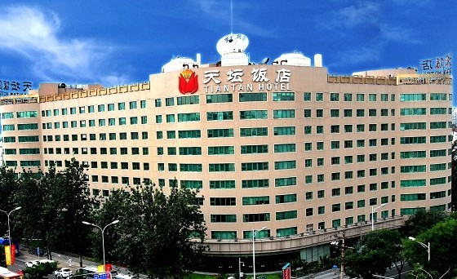
Tiantan hotel, a brand four-star hotel which located at Ti Yu Guan Road in downtown Beijing and is convenient for business and leisure travelers. It is just minutes from some of the world’s most popular tourist attractions like the Temple of Heaven and Tiananmen Square. The hotel now has 318 standard rooms and suits, Chinese and western restaurants, special bars, many recreation and entertainment facilities. Room facilities include alarm clock, free newspaper, safe deposit box, refrigerator-freezer, TV, air conditioning, direct dial telephone and internet access.
It is strongly recommended that participants stay at the Tiantan Hotel where the organizing committee has secured a block of rooms for workshop participants at special rates. Please see below the charts for charges per night:

Tiantan Hotel

Room Type | Special Rate | Bed Type | Inventory
Standard(D/S) Room | Single $44 | 2mX1.55m | 85
Standard(D/S) Room | Double $50 | 2mX1.15m | 85
Executive Room | $66 | 2mX1.8m | 30
Suite King | $73 | 2mx1.8m | 17
Suite Superior King | $88 | 2mX2m | 16
Executive Suite | $95 | 2mX2m | 6

The price based on the exchange rate as of November 2010 (1 USD = 6.64 RMB). The price includes tax and service charge. Breakfast is not included, if you want to have breakfast in the hotel, 30RMB （$4.4）for each person. This is a special discounted rate for Workshop participants only (after a 50% discount). When you make your hotel reservation, mention the National Bureau of Statistics of China (NBS) and that you are attending the Workshop.

For reservations:

Tiantan Hotel Person in Charge: Ms. Carina LI

Phone: 86-134-3646-5983
Tel： 86-10-67190389
Fax： 86-10-67190333
E-mail： carina_li1026@163.com

Upon request the organizers will assist with hotel reservation. The participants can email Ms. Carina LI to reserve the hotel room and the deposit could be paid upon check in.

- Local information

A: Arrival at the airport

Participants should make their own transportation arrangements from Beijing Capital International Airport to their respective hotels. Limousine, metered-taxi, and bus services are readily available at the airport. Payment should be made in Chinese currency, Renminbi (RMB), for which foreign currency may be exchanged through authorized counters at the airport. It is about 40 minutes driving from the airport to the hotel. Transportation charges from Airport to the Venue should be between RMB 90-110.
If you take the subway, just need 35 minutes (Arrive at The Dongzhimen Station first, then transfer to Line 5, get off at Tiantan Dong Men).

B: Exchange rate

Exchange rate as of November 2010: 1 USD = 6.64 RMB

C: Weather

The average daily temperature in Beijing during November is 10°C - 0°C.

D: Visa information

Participants will have to apply for visa to enter the People’s Republic of China.

E: For convenience, we suggest participants could give one of the below cards to the taxi driver for hotel address in Chinese:

Please drive me to the Tiantan Hotel

Address: No. 1 Ti Yu Guan Road, Dongcheng District，Beijing

Tel: (86-10) 6719 0666

请把我送到天坛饭店
地址：北京市东城区体育馆路1号
电话：(86-10) 6719 0666

